Introduction to C++

Objective

History of C++

Facts

Feautures of C++

History of C++

Bjarne Stroustrup, Born Dec 30, 1950. Aarhus, Denmark

1978 to 1979 ( was working and Launch C with Classes)

Reference c language and simula 67.

AT & T’s Bell Labs, Murray Hill, New Jersey, USA

During 1970 Dennis Ritchie created C Programming language. also at Bell Laboratories,

In 1983 ( named c++ )

Facts

C++ OOP aspect was inspired by a computer simulation language called Simula67.

When Bjarne Stroustrup was doing work for his Ph.D thesis. One of the language Stroustrup had the opportunity to work with was a language called Simula.

JAVA is written in C++

Major operating systems of modern times are written in c++.

C++ is world 4th most used programming language.(Ranking Depend on different perceptions).

Features of C++

C++ is a middle level language

C++ supports principles of object oriented paradigm.

C++ joins three separate programming traditions.

The procedural language tradition, represented by c.

The object oriented language tradition, represented by the class enhancements , C++ adds to C.

Generic programming , support by C++ templates.

Objective

Comparison between C and C++.

C++ is a super set of C language.

C++ programs can use existing C software libraries.

C follows bottom up approach of programming.

C adopt Procedure Oriented Programming.

C++ adopt Procedure as well as Object Oriented Programming

Note: C++ is a Object Oriented Programming language, but is not purely Object Oriented, it’s features like friend and virtual are violet some of the very important OOPs features.

Objective

Object Oriented Programming

OOPs is a programming approach which revolve around the concept of “Object”.

OOP permits us to analysis a problem into a number of item called as objects and then assembles of Data/ Variable and function around this items.

Key Concept of Object Oriented Programming

Objects

Classes

Method/ Member Function

Member Variable/ Data Member

Data Hiding

Data Abstraction

Encapsulation

Inheriatance

Polymorphism

We will study about "above all Key Concept" of OOPs later.

Objective

Constants

Variable

Keywords

Constants

Any information is constant

Data = Information = Constants

Types of Constants

Primary

Integer (2, -34 , 0)

Real (3.4 , 0.06 )

Character ( Songle quote, lenghth one)

Secondary (Secondary constant made with the help of primary constant)

Array

String ( e.g “Rahul” )

Pointer

Union

Structure

Enumerator

class

In Memory Figure 2,3

Input Output in C++

Objective

Output Instuction

Input Instruction

About iostream.h

Sample Program

Output Instruction

In c, Standard Output Device is Monitor and printf() is use to send data/message to monitor

printf() is a predefined function.

In c++ , we can use cout to send data/message to monitor.

cout<< is a predefined object

The operator << is called the insertion or put to operator.

Example:

printf(“Hello World”);

cout<<(“Hello World”);

printf(“Sum of %d and %d is %d”, a,b,c);

cout<<”Sum of ”<<a<<”and ”<<b<<”is”<<c;

printf(“%d”,a+b);

cout<<a+b;

Input Instruction

In C, standard input device is keyboard and scanf() is use to receive data from keyboard.

scanf() is a predefined function.

In c++, we can use cin to input data from keyboard.

The identifier cin is a predefined object in c++.

The operator >> is known as extraction or get from operator.

Example:

scanf(“%d”, &a);

cin>>a

scanf(“%d %d”, &a, &b);

cin>>a>>b;

scanf(“%d, %f”, &a, &c);

cin>>a>>c;

Remember

According to the ANSI standard for c language, explicit declaration for predefined function is recommended but not mandatory.

ANSI standard for c++ language, explicit declaration for predefined function is compulsory.

Header Files

Predefined functions are declare in header files, so whenever you are using any predefined function in your code, you have to include specific header file that contains its declaration.

About iostream.h

We need to include header file iostream.h,it contain declaration for the identifier cout and the operator << And also for the identifier cin and operator >>.

Note: << and >> are function which make by operator overloading(we will learn later)

Header file contains declaration of identfifiers.

Identifier can be function name, variables, objects, macros etc.

endl

Inserting end l into the output stream causes the screen cursor to move to the beginning of the next line.

endl is a manipulator and it is declared in iostream.h

‘\n’ character also works as it work in c.

Example: Sample Program

#include<iostream.h> //Declaration of cin and cout

#include<conio.h> //Declaration of clrscr() and getch()

void main()

{

Int a,s;

cout<<”Enter any number”<<endl; //or cout<<”Enter any number \n”;

cin>>a;

s=a*a;

cout<<”Square of entered number is :”<<s;

getch();

}

Objective

Inline Function (Only in C++)

Benefits it function

Easy to read

Easy to Modify

Avoid rewriting of some code

Easy to debug

Better memory utilization

(function takes memory when needed and release memory when task completed)

(100 KB program can be complete their task in 64 KB memory)

Advantage:

Function in a program is to save memory space which becomes appreciate when a function is likely to be called many times.

Disadvantage:

Function is time consuming

However every time a function is called. It takes lot of extra timein executing a series of instruction for task such as jumping to the functions, saving registers, pushing arguments into the stack and returning to the calling function

Solution:

So when function is small it is worthless to spend so much extra time in such task in cost of saving comparatively small space.

Inline function
To eliminate the cost of calls to small functions, c++ proposes a new features called inline function.
An inline function is a function that is expanded in line when it is invoked.
Imp: Compiler replaces the function call with the corresponding function code

Inline function is a request

Inline is a request not a command.
The benefit of speed of inline functions reduces as the function grows in size.
The compiler may ignore the request in some situations.

Few of them :
Function containing loops, switch, goto.
Function with recursion
Containing static variable.
Containing many argument and variable

Example:

#include<iostream.h>
inline void fun(); //Inline function Declaration
void main()
{
cout<<”You are in main”;
fun(); // function call
}

void fun()
{
cout<<”You are in fun”; // function Definition
}

Paradigms (Way of Doing thing)

Programing Paradigm

Procedural Programming (Use in C or C++)
Object based Programming
Object Oriented Programming

Object Oriented Programming
Object Based Programming
Procedural Programming

Procedural Programming :
Define the method of designing and implementing program using the key feautures and building blocks of a programming language.
Lays more emphasis on procedure than data.

Limitations: Modification in code takes more time.
- No Encapsulation

Object Based Programming
In this we are used class

Advantage of Class
-Information hiding
-Abstraction

We can hide unnecessary background details.
End user’s main concern is the c’ease of operation’

Example : ATM (Data Abstraction)
: Car , Bike

Advantages :

Localizes changes in the code
Hide implementation details
Support user defined data types.
Support data abstraction

Limitation: inheritance not exist.
Object Oriented Programming

OOP is superset of OBP
Note : OOP implement inheritance to overcome limitation of OBP

Object Oriented Programming Concepts.
Data Abstraction
Data Hiding
Data Encapsulation
Inheritance
Polymorphism

Data Hiding
Abstraction is made hidden from the user by making them private. With encapsulation we can accomplish data hiding. This is known as data hiding.

Data Abstraction
Abstraction directs to the procedure of representing essential features without including the background details. Hiding internal details and showing functionality is known as abstraction.

for e.g phone call, we don’t know the internal processing.

Data Encapsulation

C++ supports the features of encapsulation using classes. The packing of data and functions into a single component is known as encapsulations.
For example : capsule, it is wrapped with different medicines.

Classes encapsulate (i.e , wrap) attributes and member functions into objects and this is known as encapsulation.

Inheritance

A CLASS inherits properties from some other CLASS

Polymorphism
“Poly” is Greek word means many , and “morph” means form.

Polymorphism is implemented in C++ with two types:

- Complile Time Polymorphism
- Function Overloading
- Operator Overloading

- Run Time Polymorphism
- Virtual Function

Polymorphism makes possible the same function to act differently on different classes. It is an important features of OOP concept.

We will learn Function Overloading, Operator Overloading and Virtual Function later.

****************************************

CLASSES AND OBJECT
C++’s originator Stroustrup initially gave c++ the name “C with Clases” later it was named C++.

Classes
Structure + Function

Why use Classes?
Ans: To represent real world entities !!!
Example:
Entities : Car
Properties : Max Speed, Millage, Gear
Entities : Account
Properties : Balance, Interest

Classes And Object

Concept of Classes and Object

Class is a blue print / structure of an Object.

Class is a description of Object’s property set and set of operations.

Creating class is as good as defining a new data types/ user defined data types/ non primitive datatypes.

Class is an means to achieve encapsulation.

Object is a run time entity.

Object is an instance of a class.

Example

Rahul is an example of a Student

Ravi is an example of a Student

Function Overloading

If any class have multiple functions with same name but different parameters they are said to be overloaded. Function Overloading is usually used to enhance the readability of the program. If you have to perform one single operation but with different number/ types of arguments, then you can simply overload the function.

Way to overload a function
- By changing the number of arguments.
- By using different types of arguments.

Example :

Default Argument : When we mention a default value for a perameter while declaring the function. It is said to be as default argument.
In this case, even if we make a cell to the function will take the default value specified.

e.g : sum( int x , int y=0)
{
cout<<x+y;
}
void main()
{
sum(10);
sum(10,0);
sum(10,10);
}

Output : 10 10 20

Note : for the third function call, y will take 10 as value and output will become 20.

By setting default argument , we are also overloading the function. Default argument also allow you to use the same function in different situation just like function overloading.

Rules for using Default Arguments

1: Only the last argument must be given default value. You cannot have a default argument followed by non default argument
Ex :
sum(int x, int y);
sum(int x, int y = 0);
sum (int x=0, int y); // This is incorrect

2: If you default an argument, then you will have to default all the subsequent arguments after that.
Ex:
sum(int x , int y=0);
sum(int x , int y=0, int z); //incorrect
sum (int x , int y = 10 ; int z = 10); // correct

Placeholder Arguments

When arguments in a function are declared without any identifier they are called placeholder arguments.

void sum (int, int);

Such arguments can also be used with default arguments.

void sum (int, int=0);
void sum (int=0, int); //error

Ex:
#include<stdio.h>
#include<conio.h>
void fun(int , int=0);
void main()
{
clrscr();
fun(45);
fun(30, 50);
getch();
}

void fun(int x, int y)
{
int z= x+y;
printf (“ Ans is : %d \n”,z);
}

Function overloading using Default Arguments/Parameter
Advantage : No Declaration for separate functions.

Ex: Default Arguments

#include<stdio.h>
#include<conio.h>
void main()
{
clrscr();
cout<<avg(10);
cout<<avg(10,20);
cout<<avg(10,20,30);
getch();
}

int avg(int x)
{
int a;
a=x/2;
return a;
}

int avg(int x, int y)
{
int a;
a=x+y;
return a/2;
}

Int avg(int x, int y, int z)
{
Int a;
a= x+y+z;
return a/2;
}

Static Keyword
Static is a keyword in C++ used to give special characteristics to an element. Static elements are allocated storage only once in a program lifetime in static storage area. And they have a scope till the program lifetime. Static Keyword can be used with following,
- Static variable in functions
- Static Class Objects
- Static member Variable in class
- Static Methods in class

- Static variables inside Functions
Static variables when used inside function are initialized only once, and then they hold there value even through function calls.
These static variables are stored on static storage area , not in stack.
void counter()
{
static int count=0; // try without static and see o/p
cout << count++;
}

int main(0
{
for(int i=0;i<5;i++)
{
counter();
}
}

O/P : 0 1 2 3 4

Note : If you are doesn’t initialize a static variable, they are by default initialiazed to zero.

2. Static class Objects
An object become static when static keyword is used in its declaration.
Ex: Test t; // stack based object
static Test t1; // static object

Stack based object are also called automatic object or local objects.
Static objects are allocated storage in static storage area. static object is destroyed at the termination of program.
Ex:
#include<iostream>
#using namespace std;
class Test
{
public ;
Test()
{
cout<<" Constructor is executed ";
}
~Test()
{
cout<<" Destructor is executed ";
}
};
void myfun()
{
static Test obj;
}
int main()
{
cout<<"main() start \n";
myfun();
cout<<"main() terminates \n ";
return 0;
}

O/P : main() starts
constructor is executed
main() terminates.
Destructor is executed.
If we observe the output of this program closely, we can see that destructor for the local object named obj is not called after it's constructor is executed because the local object is static so it has scope till the lifetime of program so it's destructor will be called when main() terminates.

- Static Data Member / Member variable in Class
Static data members of class are those members which are shared by all the objects. Static data member has a single piece of storage, and is not available as separate copy with each object, like other non-static data members.
Static member variables can’t initialized in the class definition. And they are not initializated using constructor, because these are not dependent on object initialization.
Also, it must be defined or initialized explicitly, always outside the class. If not initialized, Linker will give error.
By default static member initialize with 0.

Ex:

class X
{
Static int a;
Public :

Void show()
{
cout<<” a is : ”< i ;
}

Int abc::a; //necessary to declare like this (using membership label)

}

void main()
{
clrscr();

X obj ;

obj.show();

cout<<abc:: a; // if static variable is in public specifier.
cout<<obj.a;

getch();
}

Note : In above e.g “ a ” ids not a part of object. If object is not created then still “a” variable is exist in a program. The memory of “a” variable/ static member is not depend on object.

Some Imp Points

- Declared inside the class body.
- Also known as class member variable.
- They must be defined outside the class.
- Static member variable doesn’t belong to any object, but to the whole class.
- There will be only one copy of static member variable for the whole class.
- Any object can use the same copy of class variable.
- They can also be used with class name ( iff variable declare in public specifier).

- Static Member Function / Static Methods in class
They are qualified with keyword static.
They are also called class member functions
They can be invoked with or without object.
Without object to call a static member function by itself, using class name and scope resolution :: operator
These function cannot access ordinary data members and member functions, but only static data member functions.
It doesn’t have any “this” keyword which is the reason it cannot access ordinary members.

Need of Static Member Functions.
Q: How to set value/ access value/ change or update value of static variable without using object of class.
Ans: With the help of static Member Functions because they can be call without object and they only access/change value of static variable and static member function.
Note: It doesn’t have any “this ” keyword which is the reason it cannot access ordinary members.

Ex 1:
Class X
{
Public:
Static void f()
{ }
};

int main()
{
X::f(); //calling member function directly with class name.
}

Ex 2:
class Account
{
static float balance;
public:
static void setbalance( float b)
{

balance= b;

}
}

float Account :: balance= 200.50;

void main()
{
Account a1, a2;
a1.setbalance(400.75); // set static member value using object
Account::setbalance(400.75); //using without object.
}

Const Keyword

Constant is something that doesn’t change. In C and C++ we use the keyword const to make program elements constant.

Const keyword can be used in many context in a C++ program.
Const keyword can be used with:
- Variables
- Pointers
- Function arguments and return types
- Class Data members
- Class Member functions
- Objects
1) Constant Variables
If you make any variable as constant, using const keyword, you cannot change its value. Also, the constant variables must be initialized while declared.

int main
{
const int i = 10;
const int j = i+10; // Works fine
i++; // This leads to Compile time error
}
2) Pointers with Const
Pointers can be made const too. When we use const with pointers, we can do it in two ways, either we can apply const to what the pointer is pointing to, or we can make the pointer itself a const

    - Pointer to Const
This means that the pointer is pointing to a const variable.
const int* u;
Here, u is a pointer that points to a const int. We can also write it like,
Ex:
const char* u;
char name='A';
const char* u= &name;
*u= 'J'; //error cant change value of *u
Note: You cannot use this pointer to change the value being pointed to.

Const pointer

To make the pointer const, we have to put the const keyword to the right of the *.

Ex:

int x = 1;
int* const w = &x;

Here, w is a pointer, which is const, that points to an int. Now we can't change the pointer but can change the value that it points to.

Ex: int x=1;
int y= 2;

int * const w = &x;
w=&y; // error, can't change address stored in the pointer

Note : The location stored in the pointer cannot change , you cannot change where this pointer points.
NOTE : We can also have a const pointer pointing to a const variable.
e.g : const int* const x;
3) Const Function Arguments and Return types

Learn Left

4) Const class Data members
These are data variables in class which are made const. They are not initialized during declaration.
They are not inialized during declaration.
Note: Their initialization are not occur in the constructor.

IMP: Their initializer occur with the help of initializer list by making explicit default constructor.

Ex: Using constructor, they show an error
class Test
{
const int i;
public:
Test(int x) // explicit one argument constructor
{
i=x;
}
};
void main()
{
Test t(10);
Test s(20);
}
Note: Program has Compile time error, cannot modify a const object. constant member 'x' is not initialized.

Ex: Using initializer ist
class Test
{
int a,b;
const int x;
public:
Test() : x(7) // using initializer list with explicit default constructor.
{
a=67;
b=78;
}
void show()
{
cout<<" a is "<< a << "\n b is " <<b <<"\n x is "<<x ;
}
};

void main()
{
clrscr();
Test obj;
obj.show();
getch();
}

O/P
a is 67
b is 78
x is 7

Note: x is a const data member, once initialized, it cannot be changed

5) a. Const class Object
When an object is declared or created with const, its data members can never be changed, during object's lifetime.
Syntax :
const class_name object;

b. Const class Member function
A const member function never modifies data members in an object.
Syntax :
return_type function_name() const;

In below example we can see that const member function never changes data members of class, it can be used with both const and non const object.

Const object can’t be used with a non const member function which tries to change it’s data members.

Ex: for const Object and const Member function
Class abc
{
Int I;
Public :

abc( int x )
{
i=x;
}

int f() const
{
I++;
}

int g()
{
i++;
}
};

void main()
{
abc obj1(10); // Non const Object
const abc obj2(20); // Const Object
obj1.f(); // No error
obj2.f(); // No error
cout << obj1.i << obj2.i ;

obj1.g(); // No error
obj2.g(); // Compile time error
}

O/P : 10 20

Imp Note : Here, we can see, that const member function never changes data members of class, and it can be used with both const and non-const object. But a const object can't be used with a member function which tries to change its data members.

Mutable Keyword
Mutable keyword is used with member variables of class, which we want to change even if the object is of const type. Hence, mutable data members of a const objects can be modified.
class abc
{
int i;
mutable int j;
public:
abc()
{
//check i=0;
j=0;
}
void f() const
{
Try => i++; // Error
Try => j++; // Works, because j is Mutable
}
};
void main(0
{
const abc obj;
obj.f();
}

Volatile Keyword

The reason for having this qualifier is mainly to do with the problems that encountered in real time or emebedded systems programming.

Volatile Variables

- Indicates that a variable can be changed by a background routin.

- Every reference to the variable will reload the contents from memory rather than take advantage of situation where a copy can be in a register.

- Volatile means the storage is likely to change anytime by code outside the control of the user program It means that if you reference a variable, the program should always read from the physical address and not its cached value.

- A volatile keyword is an instruction to the optimizer to make sure that the variable or function is not optimized during compilation.

Example:
………….
………….
Int A=1;
while (A);

……………

In the above example, on compilation, the compiler assume that the value of the A won’t be changed during the execution of the program. So the compiler is free to ignore the while(A) loop instructions during optimization.

However , if the A variable is changed outside this program control( say by an interrupt routine or by some other thread) then it is advisable to declare the A as a volatile variable.

Constructor in C++ & Constructor Overloading

- Constructor is a member function of a class
- The name of the constructor is same as the name of the class
- It has no return type, so can’t use return keyword.
- C++ constructor does not return even void as return type.
- It must be an instance member function, that is, it can never be static.

Note: Constructor written in public specifier.

Ques: How to call Constructor ?
Ans : i. Constructor is implicitly invoked when an object is created.
ii. Constructor is used to solve problem of initialization

The use of constructor comes when we have to initialize the members of an object, as soon as the object is created i.e not by calling explicitly to a function.

Example :

#
#
class Example
{
private :
int a,b;

public :

Example()
{
cout<< ” Hello Constructor ”;
};
}

void main()
{
clrscr();
Example c1, c2, c3;
getch();
}

Note : constructor run with respect to object, Because constructor is a instance member function.

What is problem of initialization ?

- Why it is called constructor ?
- What is problem of initialization ?
- How constructor resolve this issue ?
Constructor is basically used for initializing the variables at the time of creation of object.

Objective

- Default Constructor
- Parameterized constructor
- Constructor Overloading
( two or more than two constructor in class make Constructor Overloading)

Example 1:
#
#
class Example
{
private:
int a,b;

public :

Example() // Explicit zero parameter construct or Explicit default constructor
{
a=0;
b=0;
}

Example(int k) // Parameterized constructor

{
a=k;
}

Example( int x, int y) // Parameterized constructor
{
a=x;
b=y;
}

};

void main()
{
clrscr();
Example c1(3,4), c2(5), c3, c4;

OR Example c1=Example(3,4), c= Example(5), c3, c4;

OR Example c1 = Example(3,4), c2=5, c3=9 // like c2 and c3 are only for single parameter(we can dymically assign value , see e.g. 2)

getch();
}

Ex 2: Dynamically initialize member variable with the help of constructor

#include<iostream.h>
#include<conio.h>
class abc
{
int a;

public:

abc()
{
a=0;
}

abc(int k)
{
a=k;
}

void show()
{
cout<<"value of a is \n"<<a;
}
} ;

void main()
{
clrscr();
int z;

cout<<"Enter the value of A\n";
cin>>z;

abc obj, obj2=z;
obj2.show();

getch();
}

IMP Note: For zero parameter object, compiler make implicit default constructor(zero parameter constructor).
But if we make anyone user define constructor(parameterized constructor) in class than compiler doesn’t make implicit default constructor(zero parameter constructor). In this case we had had to make explicit default constructor(zero parameter constructor) for zero parameter object.

Ex 3:

#
#
class Complex
{
private:

int a, b;

public :

};

void main()
{
clrscr();
Complex c1, c2;
getch(); //no error
}

Note :
In above example compiler make implicit default construct, this implicit default construct made only for zero parameter object.

Ex:
#
#
Class Complex
{
private:

int a,b;

public:
Complex(int x, int y)
{
a=x;
b=y;
}
};

void main()
{
clrscr();
Complex c1(3,4), c2; //Show error
getch();
}

Note:
If any user defined constructor made in class then compiler doesn’t make default constructor for zero parameter object.

#
#
class Complex
{
private :
int a,b;

public:

Complex (int x, int y) //Parameterized Constructor
{
a=x;
b=y;
}

Complex (int k) //Parameterized Constructor
{
a=k;
}

Complex() // default constructor
{

}

};

void main()
{

clrscr();

Complex c1(3,4), c2 ;

getch();

}

Copy Constructor

The copy constructor is a constructor which creates an object by initializing it with an object of the same class, which has been created previously.

All member values of one object can be assigned to the other object using copy constructor.

For copying the object values, both objects must belong to same class.

Ex:
#include<iostream.h>
#include<conio.h>
class Complex
{
int a,b ;

public :
Complex(){
}

Complex ( int x, int y)
{
a=x;
b=y;
}

Complex(int k)
{
a=k;
}

Complex (Complex &c) // Copy Constructor
{
a=c.a;
b=c.b;
}
void show()
{
cout<<"\na is "<<a<<"\nb is "<<b;
}
};

void main()
{
clrscr();

Complex c1(3,4), c2, c3(5);
//Complex c4(c1);
Complex c4=c1;
c1.show();
c4.show();
getch();
}

Note :

Compiler make two implicit constructor

- Default implicit constructor for zero parameter object
- Copy constructor for object as an argument

C++ uses the default copy constructor which copies each field. So there is no need to define it explicitly.

Destructor

- Destructor is an instance member function of a class
- The name of the destructor is same as the name of a class but preceded by tilde(~) symbol.
- Destructor can never be static
- Destructor has no return type
- Destructor takes no arguments(No overloading is possible)
- These are used to release the memory.
- These are invoked automatically/ implicitly when object of that class is destructed.
- These are always public. They can never call if it is in private.

Why Destructor ?

It should be defined to release resources allocated to an object.
Resources
Pointer
Object

RAM

Operator Overloading

When an operator is overloaded with multiple jobs, it is known as operator overloading.

It is a way to implement compile time polymorphism.

Rules to Remember

- Any symbol can be used as function name.

- If it is a valid operator in C language.

- If it is preceded by operator keyword.

- You can not overload sizeof() and ?: operator.

Operator Overloading gives the operator to perform the operation on non primitive data types.

Example : Operator overloading for Binary Operator

#include<iostream.h>
#include<conio.h>
Class Complex
{
private:

public :
void setData(int x, int y)
{

a=x;
b=y;
}

void showData(int x, int y)
{
cout<<”\n a =”<< a<<”\n b =”<<b;
}

Complex add(Complex c) / Complex operator+(Complex c)
{
Complex temp;
temp.a = a+c.a;
temp.b=b+c.b;
return (temp);
}

};

void main()
{
clrscr();
Complex c1,c2,c3;
c1.setData(3,4);
c2.setData(5,6);
c3=c1.add(c2); //or c3=c1.operator+(c2); // or c3=c1+c2;
c3.showData();
getch();
}

Note : In binary operator overloading the left operator is always caller object. (e.g: c3=c1+c2;)

Example 2 : Operator Overloading For unary operator ( -Variable )

#include<iostream.h>
#include<conio.h>
Class Complex
{
private :

int a,b;

public :

void setData( int x, int y)
{
a=x; b=y;
}

void showData()
{
cout<<”\n a = ”<<a<<”\n b = ”<<b;
}

Complex operator-()
{
Complex temp;
temp.a=-a;
temp.b=-b;
return (temp);
}
};

void main()
{
Complex c1,c2;
c1.setData(4,5);
c2=-c1; // or c2=c1.operator-();
c2.showData();
}

Note: In Unary Operator overloading the operand is single so it’s written same as we use unary operator in c language

Example 3 : Operator Overloading For unary operator (++ / -- Pre and Post )

#include<iostream.h>
#include<conio.h>
class Integer
{
private:
int x;

public:

void setData( int a)
{
x=a;
}

void showData()
{
cout<<"\n \n X is "<<x;
}
Integer operator ++() // pre increment
{
Integer i ;
i.x = ++x ;
return (i);
}

Integer operator ++(int) // post increment
//( int use only for make difference b/w pre & post overloading function, no argu taken, no other use)
{
Integer i ;
i.x = x++ ;
return (i);
}
};

void main()
{
clrscr();
Integer i1, i2, i3;

i1.setData(3);
i1.showData();

i2=i1++; // or i2= i1.operator++(int);
i3=++i1; // or i3=i1.operator++();

i1.showData();
i2.showData();
i3.showData();

getch();

}
O/P 3 5 3 5

Friend Function

- Friend Function is not a member function of a class to which it is a friend.
- Friend Function is declared in the class with friend keyword.
E,g = > friend void fun(Complex) ; (Complex is a class)

- It must be defined outside the class to which it is friend.
- Friend function can access any member of the class to which it is friend.
- Friend function cannot access member of the class directly.
- It has no caller object.
- It should not be defined with membership label.
- Friend function can be declare in public or private because this are not a member function work for both is same.

Note:
Friend Function can become friend to more than one class.
It may be work as accessor or mutator function with the help of reference object.

We will make some Example on:
- PROGRAM FOR ADD TWO NO using FRIEND FUNTION
- PROGRAM FOR ADD TWO COMPLEX NO./ NON PRIMITIVE NO using FRIEND FUNCTION
- FRIEND FUNCTION, Overloading of insertion and extraction operator as a friend function
- UNARY OPERATOR OVERLOADING AS FRIEND FUNCTION
- FRIEND FUNCTION PROGRAM FOR ADD TWO COMPLEX NO./ NON PRIMITIVE NO. USING OPERATOR OVERLOADING AS A FRIEND FUNCTION
- FRIEND FUNCTION CAN BECOME FRIEND TO MORE THAN ONE CLASS. PROGRAM TO COMPARE TWO NO.
- MEMBER FUNCTION OF ONE CLASS CAN BECOME FRIEND TO ANOTHER CLASS

Example 1: PROGRAM FOR ADD TWO NO using FRIEND FUNTION

#include<iostream.h>
#include<conio.h>
class sum
{
int a, b;

public:

void show()
{
cout<<"A is : "<<a<<"\n";
cout<<"B is : "<<b<<"\n";
}
void set(int x, int y)
{
a=x;
b=y;
}

friend void add(sum); //FRIEND FUNTION DECLARATION
};

void add(sum z) //FRIEND FUNCTION DEFINATION
{
cout<<"Sum is : "<<z.a+z.b;
}

void main()
{
clrscr();
sum obj;
obj.set(6,7);
obj.show();
add(obj); //FRIEND FUNCTION CALLING
getch();
}
O/P : A is : 6 B is : 7 Sum is : 13

Example 2 : PROGRAM FOR ADD TWO COMPLEX NO./ NON PRIMITIVE NO using FRIEND FUNCTION

#include<iostream.h>
#include<conio.h>
class Complex
{
private:
int a, b;
public:
void setvalue(int x, int y)
{
a=x;
b=y;
}
void showvalue()
{
cout<<a<<" "<<b;
}

friend Complex add(Complex, Complex); //friend funtion declaration

};
Complex add(Complex c, Complex d) //friend funtion defination
{
Complex z;
z.a=c.a+d.a;
z.b=c.b+d.b;
return z;
}

void main()
{
clrscr();
Complex obj1, obj2, obj3;
obj1.setvalue(5,8);
obj2.setvalue(2,1);
obj3=add(obj1,obj2);
//cout<<obj3.a<<" "<<obj3.b; //if class member variable is public
obj3.showvalue();
getch();
}

O/P : 7 9

Example 3 : FRIEND FUNCTION CAN BECOME FRIEND TO MORE THAN ONE CLASS. PROGRAM TO COMPARE TWO NO.

#include<iostream.h>
#include<conio.h>
class xyz;
class abc //CLASS 1
{
private:
int a;
public:
void setvalue(int x)
{
a=x;
}
void showvalue()
{
cout<<" 1st Value is :"<<a<<"\n";
}
friend void fun(abc, xyz); //Friend Funtion Declaration
};

class xyz //CLASS 2
{
private:
int a;
public:
void setvalue(int x)
{
a=x;
}
void showvalue()
{
cout<<"2nd Value is :"<<a<<"\n";
}
friend void fun(abc, xyz); //Friend Funtion Declaration
};

void fun(abc c, xyz d) //Friend Funtion Defination
{
if(c.a>d.a)
cout<<c.a<<" is greater\n" ;
else if(d.a>c.a)
cout<<d.a<<" is greater\n";
else
cout<<c.a<<" and "<<d.a<<" are equal\n";
}

void main()
{
clrscr();
abc obj1;
xyz obj2;
obj1.setvalue(9);
obj2.setvalue(7);
fun(obj1,obj2);
getch();
}

Example 4 : FRIEND FUNCTION PROGRAM FOR ADD TWO COMPLEX NO./ NON PRIMITIVE NO. USING OPERATOR OVERLOADING AS A FRIEND FUNCTION

#include<iostream.h>
#include<conio.h>
class Complex{
private:
int a, b;
public:
void setvalue(int x, int y)
{
a=x;
b=y;
}
void showvalue()
{
cout<<"Value of Object is :"<<a<<" "<<b<<"\n";
}

friend Complex operator+(Complex, Complex); //Friend Funtion Declaration

};
Complex operator+(Complex c, Complex d) //Friend Funtion Defination
{
Complex z;
z.a=c.a+d.a;
z.b=c.b+d.b;
return z;
}

void main()
{
clrscr();
Complex obj1, obj2, obj3;
obj1.setvalue(5,8);
obj2.setvalue(2,1);
obj1.showvalue();
obj2.showvalue();
//obj3=add(obj1,obj2); //FRIEND FUNCTION CALL
obj3=obj1+obj2; //FRIEND FUNCTION CALL USING OPERATOR OVERLOADING
obj3.showvalue();
getch();
}

Example 5: FRIEND FUNCTION, Overloading of insertion and extraction operator as a friend function

#include<iostream.h>
#include<conio.h>
class Complex{
private:
int a,b;
public:
void setvalue(int x, int y)
{
a=x;
b=y;
}
void showvalue()
{
cout<<a<<" "<<b;
}

friend ostream& operator<<(ostream&,Complex); //friend funtion declaration
friend istream& operator>>(istream&, Complex&);
};

ostream& operator<<(ostream &dop, Complex d) //friend funtion defination
{
cout<<"A is : "<<d.a<<"\n"<<"B is : "<<d.b;
return dop;
}

istream& operator>>(istream &don, Complex &d) //friend funtion defination
{
cin>>d.a>>d.b;
return don;
}

void main()
{
clrscr();
Complex c1;
cout<<"Enter Complex No.\n" ;
cin>>c1; // operator>>(cin,c1);
cout<<"You Type no is :\n";
cout<<c1; // opeartor<<(cout,c1);
getch();
}

/*
Note:
ostream is the type of object cout.
istream is the type of object cin.
we return value in both the friend function because
use of e.g: cin>>c1>>c2; mean they return cin/cout
*/

Example 6 :UNARY OPERATOR OVERLOADING AS FRIEND FUNCTION

#include<iostream.h>
#include<conio.h>
class Complex{
int a, b;

public:

void set(int x, int y)
{
a=x;
b=y;
}

void show()
{
cout<<a<<"\n";
cout<<b<<"\n";
}

friend Complex operator-(Complex); //FRIEND FUNCTION

};

Complex operator-(Complex c)
{
Complex z;
z.a=-c.a;
z.b=-c.b;
return z;
}

void main()
{
clrscr();
Complex obj1,obj2;
obj1.set(5,9);
obj2=-obj1; //obj2=operator-(c1) //Friend Function Call
obj1.show();
obj2.show();
getch();
}

Example 7: MEMBER FUNCTION OF ONE CLASS CAN BECOME FRIEND TO ANOTHER CLASS

#include<iostream.h>
#include<conio.h>

class A
{
Public:
void fun()
{
……………
………….
}

void foo()
{
…………..
………….
}
};

class B
{
friend class A; // for make all function in class A as a friend of class B
// friend void A:: fun();
// friend void A:: foo();
};

void main()
{

}

Inheriatnce

Inheriatance allow creating classes which are derived from other classes, so that they automatically include member of its parent class, plus it’s pwn.

It is a process of inheriting properties and behaviours of existing class into a new class.

Base class : The class from which the other class is derived is called base class or parent class or super class or existing class or old class.

Derived class : The class which is defined from base class is called derived class or children class or sub class or new class.

Features :
- It include re-usablity
- Base class is more general while derived class is more specific.

Example:
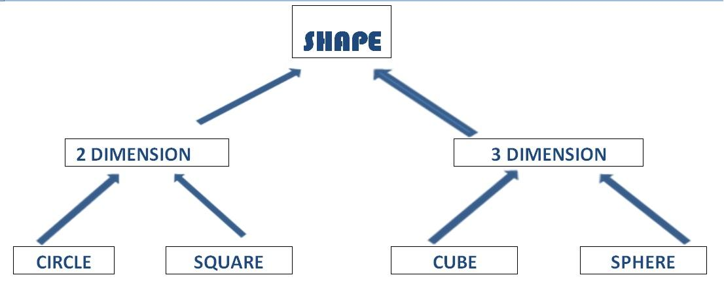

Understand the need of Inheriatnce

- Class is used to describe properties and behavior of an object.
- Property names and values
- Behaviour means action

Advantage : Reduced Cost, Time for making some method or function for their properties

Ex: Let us assume what we want to represent a car

CAR

Properties : Price, Fuel type, engine, colour , capacity

Method : setPrice() , setFuelType(), setEngine(), setcolour() , setCapacity()
getprice(), getFuelType(), getEngine(), getcolour() , getCapacity()
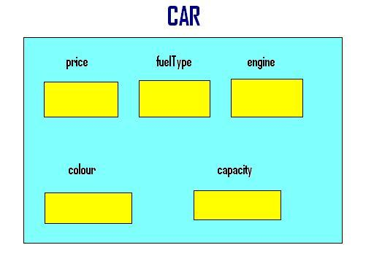

Sports Car

Properties : price, fueltype, engine, colour, capacity

Properties : alarm, navigator, safeguard

Method : setAlarm(), setNavigator(), safeGuard(), getAlarm(), getNavigator(), getSafeGuard()

Method : setPrice() , setFuelType(), setEngine(), setcolour() , setCapacity()
getprice(), getFuelType(), getEngine(), getcolour() , getCapacity()

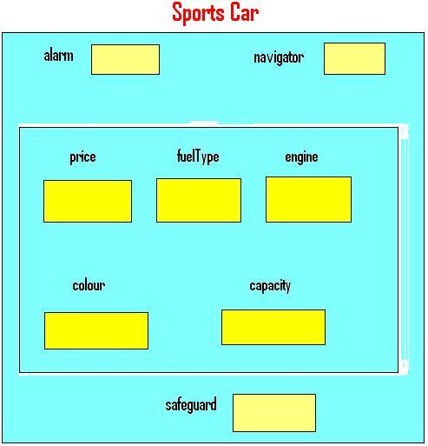

Syntax :

Class Base_Class
{

};

Class Derived_class : Visibility_Mode Base_class
{

}

Visibilty_Mode

Access Specifier

- Private
- Protected
- public

Access Specifiers
Accessibility Rules/ Labels
- Private : No Direct Access
- Protected : No Direct Access
- Public - Direct Access

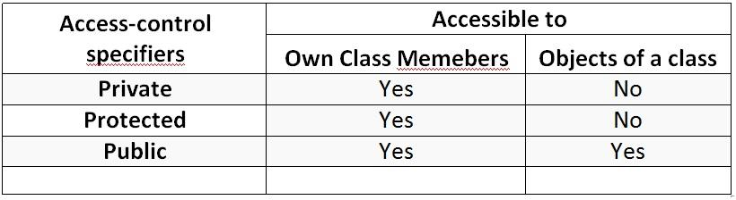

Example :

class Car
{
…………..
…………..
};

class SportCar : public Car // class SportCar : Car ( default private)
{
…………………..
…………………..
};

Types of Inheritance

- Single Inheritance
- Multilevel Inheritance
- Multiple Inheritance
- Hierarchical Inheritance
- Hybrid Inheritance

Single Inheritance

class A
{
…
…
};

class B : public A
{
……..
……..
};

A

B

Multilevel Inheritance

Class A
{

};

Class B: public A
{

};

Class C: public B
{

};

Note: C consist all member which have A as well as B.
In this the Parent class of C is Only B not A

A

B

C

Multiple Inheriatnce

Multilevel Inheritance

Class A1
{

};

Class A2
{

};

Class B: public A1, public A2
{

};

B

A1

A2

Hierarchical Inheritance

Class A
{
……
};

Class B1 : public A
{
……
};

Class B2 : public A
{
….
};

A

B1

B2

Visibility Modes :

Prerequisite: Access Specifier

Inheritance Visibility Mode
Depending on Access modifier used while inheritance, the availability of class members of Super class in the sub class changes. It can either be private, protected or public.

1) Public Inheritance

This is the most used inheritance mode. In this the protected member of super class becomes protected members of sub class and public becomes public.

class Subclass : public Superclass

2) Private Inheritance

In private mode, the protected and public members of super class become private members of derived class.

class Subclass : Superclass // By default its private inheritance

3) Protected Inheritance

In protected mode, the public and protected members of Super class becomes protected members of Sub class.

class subclass : protected Superclass

Table showing all the Visibility Modes
Base class | Derived Class | Derived Class | Derived Class
Base class | Public Mode | Private Mode | Public Mode
Private | Not Inherited | Not Inherited | Private
Protected | Protected | Private | Protected
Public | Public | Private | Public

Constructor in Inheritance
Question :

- We know that constructor in invoked implicitly when an object is created.

- In inheritance, when we create object of derived class, what will happen ?

Example 1: No need of Explicit constructor in Base Class

#include<iostream.h>
#include<conio.h>
class A //Base Class
{
Int a;
public :
A() //Compiler also make same constructor implicit
{ }

};

class B : public A //Derived class
{
public:
B( ) : A( ) or B( ) // In this case compiler make default constructor.
{ } { }
};
void main()
{
B obj ;
}

Note:
In inheritance the order of running constructor is from parent to child , But order of calling is from child to parent

Example 2: Need of Explicit constructor in Base Class

#include<iostream.h>
#include<conio.h>
class A
{
int a;
public :
A( int k) //explicit constructor
{
a=k;
}

};

class B : public A
{
public:
B( ) : A(5 ) or B( ) // In this case compiler make default constructor.
{ } { }
};

void main()
{
B obj ;
}

Note:

As we know that If we make a explicit constructor than compiler doesn’t make default constructor.
We had had to make constructor in child class if parent class doesn’t have default constructor or have explicit constructor.

Example 3: Need of Explicit constructor in Base Class

#include<iostream.h>
#include<conio.h>
class A
{
int a;
public :
A( int k) //explicit constructor
{
a=k;
}

};

class B : public A
{
public:
B(int x, int y ) : A(x ) or B( ) // In this case, compiler make default constructor.
{ } { }
};

void main()
{
B obj (2,4);
}

Destructor in Inheritance

In below example when object of B class is destroy, the destructor of B class is called and then B class destructor is run at last step B class destructor call A class destructor.
Example 1: Desructor in Inheritance

#include<iostream.h>
#include<conio.h>
class A //Base Class
{
Int a;
public :
~A() //Compiler also make same destructor implicit
{ }

};

class B : public A //Derived class
{
public:
B( ) // default destructor make by explicitly.
{ }
};
void main()
{
B obj ;
}

Note:
We had had to make destructor in child class if parent class doesn’t have default destructor or have explicit destructor.

Object Pointer

A pointer contains address of an object is called Object Pointer.

Ex:
#include<iostream.h>
#include<conio.h>

class Box;
{
private:

int l, b, h ;

public :

void setDimension(int x, int y, int z)
{

l=x; b=y; h=z;

}

void showDimension
{

cout<<"\n l="<<l<<" b="<<b<<" h="<<h;

}

};

void main()
{

Box *p, smallBox ;
p=&smallBox;

smallBox.setdimension(12,10,5);
//p->setDimension(12,10,5);

smallBox.showDimension();
//p->showDimension();

}

Note: Replace Object name with pointer which point that Object.
Replace (.) Dot Operator with (->) arrow operator.
Both the statement is same.

How pointer can access private fields of a C++ object
Example:
class Dummy
{
private :
int a , b ;

public :
void show()
{

cout<<" a ="<<a;
cout<<" b ="<<b;
}

};

main()
{
Dummy d1 ;
int *p ;

p=&d1 ;// error p is integer type and d1 is Dummy type

p=(int*)&d1 ;

*p=3;
*(p+1)=4;
d1.show();

}

Output:
a= 3
b= 4
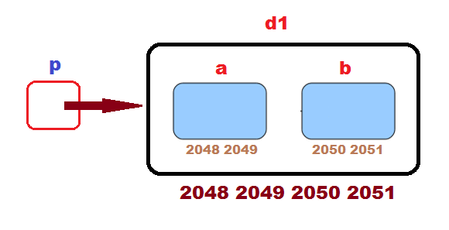 | 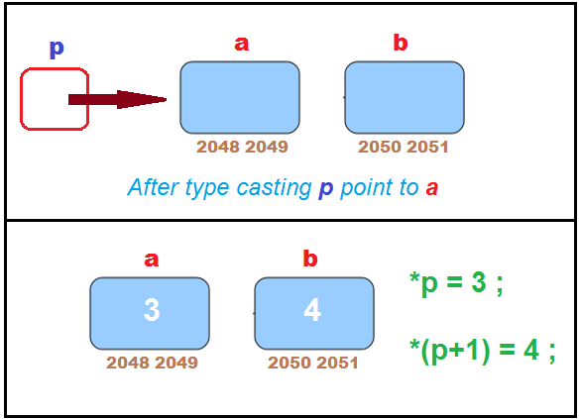

this Pointer in C++

this pointer

- this is a keyword.
- this is a local object pointer in every instance member function containing address of the caller object.
- this pointer can not be modify.
- It is used to refer caller object in member function.

Example:

#include<iostream.h>
#include<conio.h>

class Box;
{
private:

int l, b, h ;

public :

void setDimension(int l, int b, int h)
{

this->l=l; this->b=b; this->h=h;

}

void showDimension
{

cout<<"\n l ="<<l<<" b ="<<b<<" h ="<<h;

}

};

void main()
{

Box smallBox ;

smallBox.setdimension(12,10,5);

smallBox.showDimension();

}

Note:
this keyword is pass as a hidden argument when Object is created for a non static member function.

this is always available as local variable for a non static member function.

e.g:
this->x=a;
Or (*this).x=a;
Or obj.x=a;

where x is member variable & a is receiver member variable / receiver argument

Example :

#include<iostream.h>
#include<conio.h>
class student
{

int rn;
string name;

public :

void get_data(int rn, string x)
{
this->rn= rn;
name=x ;
}

void put_data()
{
cout<<"Name: "<<name<<"\n Roll No. ="<<rn ;
}

};

void main()
{

student s;
s.get_data(1,"abc");
s. put_data();

}

Another Example
#include<iostream.h>
#include<conio.h>
class Max{
private:
int no;
public:

Max greater(Max &x)
{
if(x.no>no)
{
return x;
}
else
{
return *this ; //this contain address of Obj1 coz Obj1 is caller
}
}
Max(int x)
{
no=x;
}
Max()
{

}

void disp(void)
{
cout<<"greater value :"<<no;
}
};
void main()
{
clrscr();

Max obj1(10), obj2(5), obj3;
obj3=obj1.greater(obj2);
obj3.disp();
getch();

}

Use Base Class Pointer to Derived Classes.

class B
{

}
class C: public B
{

}
void main()
{
B *ptr ;
B obj ;
ptr= &objb ;

}

Note: ptr can access members of base class
ptr can point object of derived class like

C objc ;
ptr = &objc;

In this case , ptr can only access member of Base class which are
inherited in derived class. But ptr cannot be access
itself member or derived class member because ptr pointer is
declare in base class.

Example:

#include<iostream.h>
#include<conio.h>
class Base
{
protected :
int b;
public :
void setb(int x)
{
b=x;
}

void disp(void)
{
cout<<"\n Base Class " ;
cout<<"\n Value of B "<< b ;
}
};

class Derived : public Base
{
int d;
public :
void setd(int y)
{
d=y ;
}
void disp(void)
{
cout<<"\n Derived class";
cout<<"\n Value of D "<< d;
cout<<"\n Value of B "<< b;
}
};

void main()
{
clrscr();
Base *bp;
Base b ;
bp=&b; // bp point to Base Class Object
bp->setb(100);
bp->disp();

Derived d;
bp=&d; //bp point to Derived Class Object
bp->setb(200);
bp->disp(); //disp of Base Class
//bp->setd(300); //error , invalid (early binding concept)

cout<<"\nBelow dp pointer declare in Derived Class";

Derived *dp;
dp=&d ;
dp-> setd(400);
dp->disp();

/*
cout<<"\nUsing (C Derived*)bp)";
((Derived*)bp)->setd(300);
((Derived*)bp)->disp();
*/
getch();

}

New and delete in C++

SMA : Static Memery Allocation
DMA : Dynamic Memory Allocation

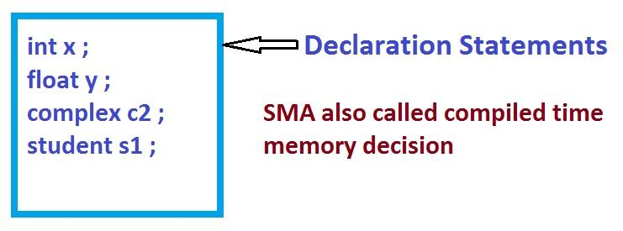

New and Delete

New
- It allow creating the object at run time.
- It is used for dynamic memory allocation

new
- int *p = new int ;
- float *q = new float ;
- Complex *ptr = new Complex ;
- float *q = new float[5] ;
- int x ;
cin>>x;
int *p= new int[x] ;

Delete
- It is used to free the dynamically allocated memory.

Delete
- delete p ;
- delete [ ]p

Note:
When written delete p then p variable not be deleted, only those variable deleted which are pointed by p.

Example :

#include<iostream.h>
#include<conio.h>
void main()
{
clrscr();
int *p;
p=new int[6];
cout<<"\nEnter one number";
cin>>*p;
cout<<"\nEnter two number";
cin>>*(p+1);
*(p+2)=*(p)+*(p+1);
cout<<"\nSum of Two Number: "<<*(p+2);
delete p; // address in p is set to free area from consumed area
getch();
}

Method overidding ,Method Hiding and Method Overloading

#include<iostream.h>
#include<conio.h>
class A
{
public :
void f1()
{}
void f2()
{}
void f3()
{}
};

class B: public A
{
void f1( ) //Method Overriding
{}
void f2(int x) //Method Hiding
{}
};

void main()
{
B obj ;
obj.f1(); // B run
obj.f2(); // error , here method overloading concept is fail bcoz both functions
are made in different classes.
obj.f2(4); // B run
obj.f3(); // A run

}

Note: If object is created of child class then function searching
start from child class to parent class.

Use of Method Overiding

Advantage and Use of Method Overidding.

If we want to change the services of inherited member function from parent class without changing the name of inherited member function name, we use method overriding.

Example:

#include<iostream.h>
#include<conio.h>

class Car
{
public :
void shiftgear()
{ }

};

class SportsCar:public Car
{
void shiftgear() // Method Overriding
{ }

}

void main()
{
SportsCar Obj; // obj is SportsCar
obj.shiftgear(); // Run for SportsCar
}

Note: We are update the shiftgear coding of SportsCar,
Due to concept of overriding function will run of Derived Class.
Called Early Binding

Function Overriding with Example

If we inherit a Base class into the derived class and provide a defination for
one of the base class function again inside the derived class, then that function
is said to be overridden, and this mechanism is called function overriding.

#include<iostream.h>
#include<conio.h>

class abc
{
protected:
int x ;

public :

void get_x(int a)
{
x=a;
}

void put()
{
cout<< "x" << x <<"\n";
}

};

class xyz : public abc
{
int y;
public :
void get(int a, int b)
{
x=a;
y=b;
}

void put() // function overriding
{
cout<<"\n X :"<<x ;
cout<<"\n Y :"<<y ;
}

};

void main()
{
clrscr();
xyz a;
a.get(5,10);
a.put();
getch();
}

Virtual Function in C++
As we Know that
Base class Pointer
- Base class pointer can point to the object of any of its descendant class.
- But its converse in is not true.

Example:
#include<stdio.h>
#include<conio.h>

class A
{
public :
virtual void f1() //late binding
{ }

}

class B:public A
{
public:
void f1() //function overriding
{ }

void f2()
{ }

}

void main()
{

A *p, Obj1;

B Obj2 ;

p=&Obj2 ;

p->f1(); //B Late binding

}

Note: Without virtual keyword f1() function call of class A.

***************

Virtual Functions :
Virtual Function is Function in base class, which is overrided in the derived class, and which tells the compiler to perform Late Binding on this function. Virtual Keyword is used to make a member function of the base class virtual.

Late Binding : In Late Binding function call is resloved at runtime. Hence, now compiler determine the type of object/type of address which point at run time, and then binds the function call. Late Binding is also called Dynamic Binding or Runtime Binding.

IMP NOte:

- Only the Base class Method's declaration needs the virtual keyword, not the definition.
- If a function is declared as virtual in the base class, it will be virtual in all its derived classes.
- If we make virtual function and its overriding occur in child class then this overrided function also be set as virtual function implicit. we have no need to make explicit virtual keyword for that overided function.
- Virtual Function always late Bind.

Example :

class Base
{
public:
void disp(void)
{
cout<<"\n Base Class disp ";
}

virtual void show(void)
{
cout<<"\n Base class Show" ;
}

};

class Derived : public Base
{
public:
void disp(void)
{
cout<<"\n Derive Class disp ";
}

void show(void)
{
cout<<"Derived class show";
}

};

void main()
{

Base *p;
Base Objb;
Derived Objd;

p=&Objb;
p->disp();
p->show(();

p=&Objd;
p->disp();
p->show();

getch();

}

Output:

Base class disp
Base class show
Base class disp
Derived class show

Note: This Type of Concept called Polymorphism

Binding
Late Binding / Run Time Binding : Check type of pointer + address which contain by this pointer
Early Binding : Address inside does not check

Virtual Function Working Concept

class A  {  *_vptr  public :  virtual void f1()  {...}  virtual void f3()  {...}  virtual void f4()  {...}  };  class B: public A  {  public :  void f1()  {...}  void f2()  {...}  void f4(int x)  {...}  }; | 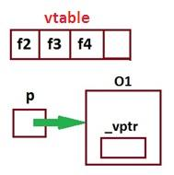  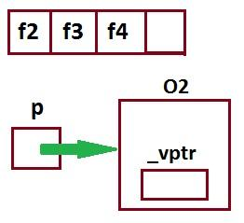 | main()  {  A *p ,O1 ;  p = &O1;  p -> f1(); // EB  p -> f2(); // LB  p -> f3(); // LB  p -> f4(); // LB  p -> f4(5); // EB , error  }  Or  main()  {  A *p ;  B O2 ;  p = &O2;  p -> f1(); // EB , A  p -> f2(); // LB  p -> f3(); // LB  p -> f4(); // LB  p -> f4(5); // EB , Overidding not occur. Error, A  }

Note:
If any class have even a virtual function, for that class compiler will declare one pointer variable as member variable as named *_vptr.
Proof variable existence: If we create an Object of that class and check size of this Object, it will return 2 byte extra size.
*_vptr doesn’t make for child classes because that already inherited from parent class.

vtable

- Compiler make a pointer variable static array , This array store the addresses of virtual function. This static pointer variable array is called a vtable.
- That vtable(static pointer variable array) make for all descendant classes individually.
- vtable doesn’t depend on Object, because it is static array , not a instance member.
- *_vptr contain address of vtable of class, when object of that class is created.

Remember :

- If we make a function virtual and that function is overrided in child class, then this overided function also called as virtual. For this function there is no need to write virtual keyword as prefix.
- Virtual function always late Bind
- vptr : A pointer to vtable. It maintained per Object.

Abstract classes and Pure Virtual in C++

Pure Virtual Function

- A do nothing function is pure virtual function
- Which class has do nothing function, that class cannot create an object. We had had to make child class for accessing that class.
- We had had to overridding that function(do nothing function) in child class.
- If we don’t override do nothing function (pure virtual function) in derived class then it(derived class) becomes abstract class.
- We had had to make do nothing function as virtual because it may be possible that pointer of base class pointed to the object of derived class and can call do nothing function by concept of Early Binding.

Example:

#include<stdio.h>
#include<conio.h>
class Person
{
public :
virtual void fun()=0; //Pure Virtual Function
void f1()
{ }
};

class Student : public Person

void main()
{
public :
void fun( )
{ }

} ;

Abstract Class

A class containing pure virtual function is an abstract class.
We can not instantiate abstract class.( Object doesn’t make).

#include<stdio.h>
#include<conio.h>
class Person
{
public :
virtual void fun()=0; //Pure Virtual Function
void f1()
{ }
};

class Student : public Person
{
public :
void fun( ) // Or virtual void fun=0 ;
{ } In this case we had had to make child class of this child class and also make overriding of fun function in new child class, without it we can’t access the member of Student and Person class because Object will not create for both class due to pure virtual function exist in both the class.

} ;

Abstract class
- The classes whose object can’t be created are called abstract class.
- These are just used for inheritance.
- If we create any pure virtual function in class then it becomes abstract class.

- If we don’t override pure virtual function in derived class then it(derived class) becomes abstract class.

Concrete Class

If we override all pure virtual function in derived class then it becomes concrete class.
The Object of these classes can be created.

Why Abstract Class ?
Generalization Concept in OOP
Example:

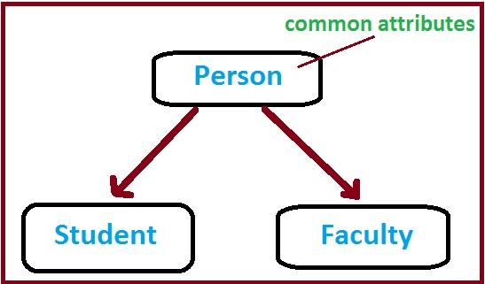

- We are not interested to storing the information about Person, So object of person class is not useful. So we are make Person class as Abstract. Because we are interested only in student and Faculty info.
Person class just build only for storing common attributes or just used for inheritance
.
- Advantage for making Pure Virtual function.
We can forced child class to define function.

Template

The Keyword template is used to define function template and class template
It is a way to make your function or class genrakize as far as data type is concern.

Example :

#include<iostream.h>
#include<conio.h>
Using namespace std;
template< class X, class Y>

X big( X a, Y b)
{

if(a>b)
return (a);

else
return (b);
}

void main()
{
cout<<big(4,5) ;
cout<<big(4.5 , 4);
cout<<big(5.6 , 3.4);
getch();
}

Example :

#include<iostream.h>
#include<conio.h>

template<class T>
T add(T a, Tb)
{
return a+b;
}

void main()
{
int z;
float r;
z = add(5, 5);
r = add(5.5 , 5.5);
cout<<z<<" \n "<< r ;
return 0 ;
}

Class Template
Class template
Class template is also known as generic class.
template<class type> class class_name{ .. };

type replace by data types in class

Advantage : We don’t need to make class for different data types.

Example:
#include<iostream.h>
#include<conio.h>
#include<stdlib.h>
const int mx=5;
template<class type>
class Stack
{
type st[mx];
int top;

public :
Stack()
{
top=-1;
}

void push(type var)
{
st[++top]=var ;
}

type pop()
{
return st[top--];
}

};

void main()
{
clrscr();
Stack<float> s1;
s1.push(1.22);
s1.push(1.25);
s1.push(1.27);

cout<<"1 :="<<s1.pop() <<endl ;
cout<<"2 :="<<s1.pop() <<endl ;
cout<<"3 :="<<s1.pop() <<endl ;

Stack<long> s2;
s1.push(123.22);
s1.push(123.25);
s1.push(134.27);

cout<<"1 :="<<s1.pop() <<endl ;
cout<<"2 :="<<s1.pop() <<endl ;
cout<<"3 :="<<s1.pop() <<endl ;

getch();

};

File Handling in C++
Data Persistence
Life of Data
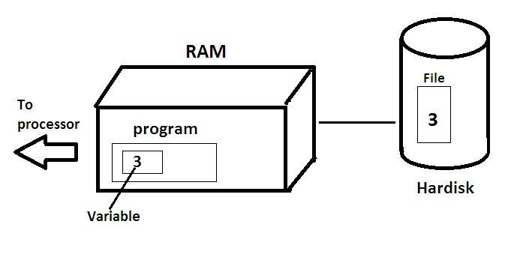

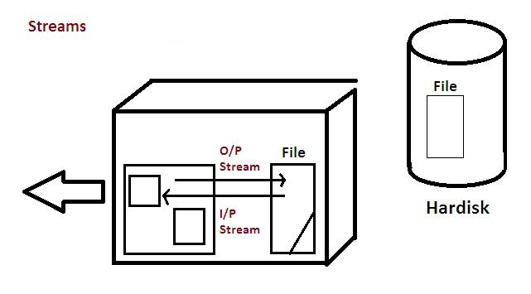

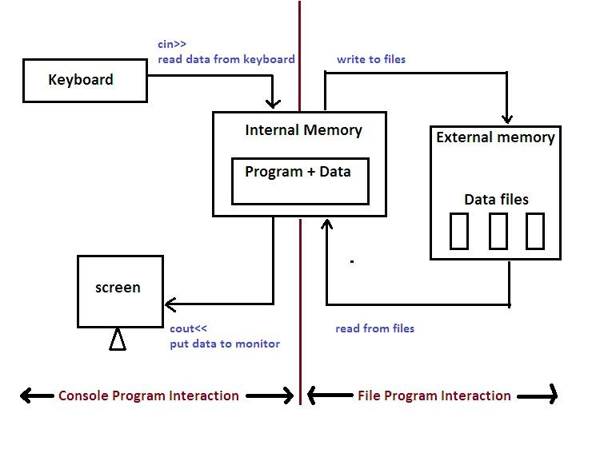
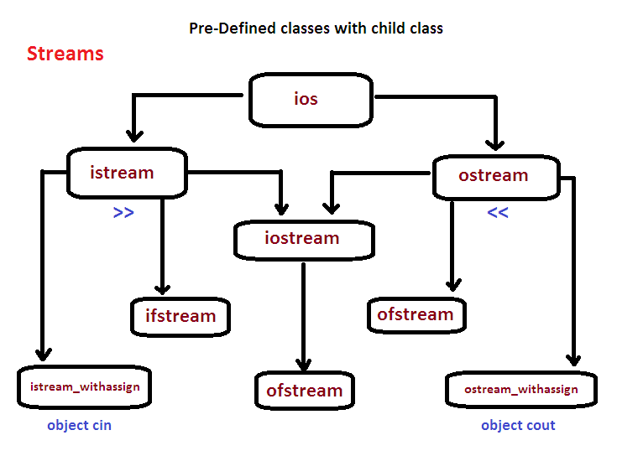

Note:
ofstream, ifstream, fstream classes are predefined, But in filehandling concept we have to make objects for these.

Example:
#include<fstream.h>
#include<iostream.h>
#include<conio.h>
void main()
{
ofstream fout; //default mode ios::out
fout.open("myfile.dat"); //file mode
getch();
fout<<"Hello";
getch(); // hello written in file of RAM
fout.close();
getch(); //hello written in file of Hardisk
}

//close(), open() and more are the method or services of class ofstream.

/*Note :
we have create an object of ifstream when we want to bring data from file.
we have create an object of ofstream when we want to write data into a file.
we have create an object of fsteam for both the operation
*/

Example:
#include<fstream.h>
#include<iostream.h>
#include<conio.h>
void main()
{
clrscr();
ifstream fin;
char ch;
fin.open("myfile.dat");
fin>>ch;
while(!fin.eof())
{
cout<<ch;
fin>>ch;
}
fin>>ch;
getch();

}
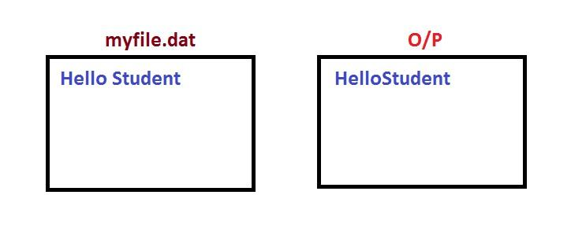
Note:
In this program Space not read because in cout<<ch ; . “<<” is operator overloading function which assume that space is special symbol. e.i they doesn’t read the space and doesn’t store in ch variable.

Example 2:
#include<fstream.h>
#include<iostream.h>
#include<conio.h>
void main()
{
clrscr();
ifstream fin;
char ch;
fin.open("myfile.dat");
ch=fin.get();
while(!fin.eof())
{
cout<<ch;
ch=fin.get();
}
fin>>ch;
getch();
}
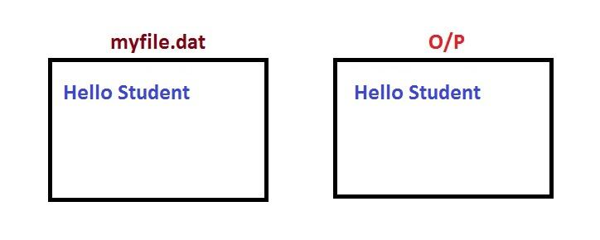
Note:
get() function read all type of content with line change and backspace.

File opening Mode in File Handling
 | MODE | PERMISION
ifstream | ios::in | Input/read
oftream | ios::out | Output/write
ofstream | ios::app | Append
ofstream | ios::ate | Update
Both | ios::binary | Binary
Both | ios::nocreate |  | If file doesn’t exist, then open fail.
Both | ios::noreplace |  | If file already exist, then open fail.
Both | ios::truck |  | Old data deleted if data exist.

Text Mode v/s Binary Mode

Text mode is the default opening mode

Binary mode can be specified with ios::binary
If we write texts in binary mode like this fout<<”My name is \n Mohit” ;. Backslash n (\n) is will as it is write in file. But in text mode or default mode , Backslash n (\n) read as escape sequence or special character so it will not write in file.And Due to its predefined meaning (line change ) it will change the line in the file.

Opening and Closing Files in C++

Suitable name for the file

Ex:

mohit.doc

Name with extension(.exe , .txt, .dat, )

Data type and structure

Depend on programer

Purpose

ifstream //read

ofstream //write

fstream //read and write // opening mode code necessary to write in this

Opening Method

File can be open in two ways.

Using the Constructor function of the class

Using the member function open() of the class

Opening Mode
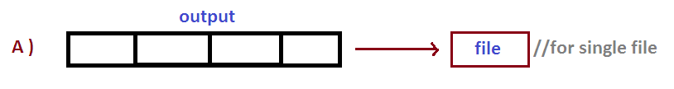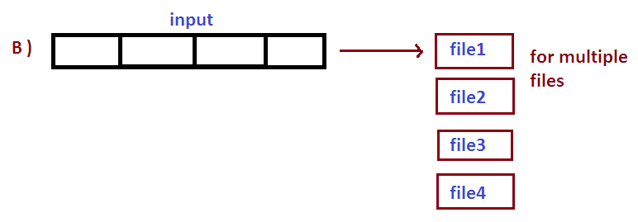
A)
1 Create object for which type of mode will perform ifstream or ofstream.
Object initialize with the file name . e.g filename
e.g : ofstream outfile
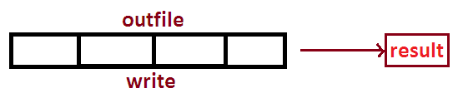
e.g: ifstream infile(“Data”);
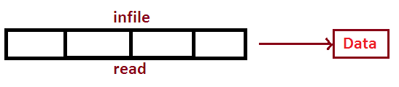

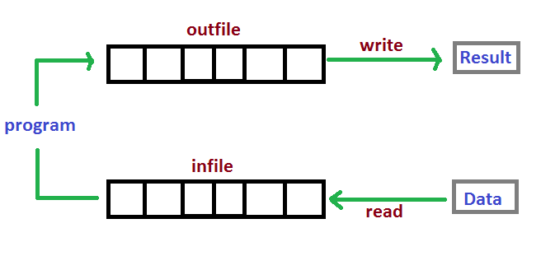
Classes ifstream and ofstream are used in one program.
Example:
ofstream outfile (“result”) ; // for opening file
if stream infile(“Data”);
outfile.close(); //for closing file
infile.close();
Note: constructor method used for managing single file.
B
Using the member function(open()) of the class. The open() can be used to manage multiples files that used the same stream objects.
Syntax:
File_stream_class stram_object;
Stream_object.open(“mohit”);

Example:
ofstream outfile;
outfile.open(“Data1”);
🡨----------
------code for write---------
----------------------🡪
outfile.close();
outfile.open(“Data2”);
//disconnect necessary for attach 2nd file. Without close() we can not connect 2nd file with ofstream
🡨----------
------code for write---------
----------------------🡪
outfile.close();

- IMP Opening file using constructor Function with Program
Digramatical Representation
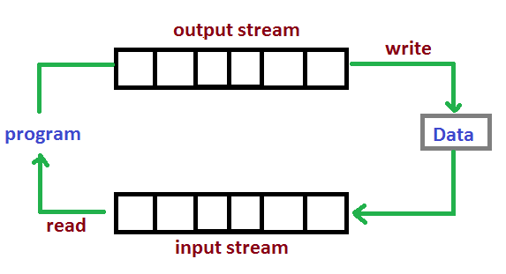

Programming Example:
#include<fstream.h>
#include<iostream.h>
#include<conio.h>
void main()
{
char name[20], name1[20];
float cost, cost1;
ofstream outf("data");

cout<<"Enter item name ";
cin>> name;

cout<<"Enter item cost";
cin>> cost;

outf<<name<<"\n";
outf<<cost<<" \n";
outf.close();

ifstream inf("data");

inf>> name1 ;
inf>> cost1 ;

cout<<"\n Item Name"<<name1;
cout<<"\n Item cost"<<cost1;

inf.close();

getch();

}

Note:
हमें data read करने के लिए उसी type के variable बनाना रहता है ! जिस type का data file में write है ! primitive data type की help से data write या read सिर्फ space के पहले तक होता है ! ofstream / ifstream के object से call हुए << या >> में !

single single character read करने से loop की help से भी << / >> function इन्हें special character या Delemeter मानकर read नहीं करता !

Note: Only read with respective data type and end limit is 1st space.
- Opening files using open() function in C++
#include<fstream.h>
#include<iostream.h>
#include<conio.h>
void main()
{
char name[20];
int cost;
ofstream fout;
fout.open("data");
fout<<"keyboard \n";
fout<<350<<" \n ";
fout.close();
ifstream fin;
fin.open("data");
fin>>name;
fin>>cost;
cout<<" \n Item name "<< name;
cout<<" \n Item cost "<< cost;
fin.close();
getch();4
}

The get() and put() function used for read and write one character at a time with spaces and newline character.

get() is member function of ifstream

put() is member function of ofstream

get()

get() used with two types

get(char*)

getc(void) //skip newline and spaces etc.

char ch;
- cin.get(ch); // Doesn’t skip newline and backspaces
Or
- ch=cin.get();

put()

cout.put(‘E’);
Or
char ch=’y’;
cout.put(ch);
Example:
#include<iostream.h>
#include<conio.h>
void main()
{

int count=0;
char ch;
cout<<"Input text";
while(ch!='\n')
{
cin.get(ch); //cin>>ch //tab, space and newline are skiped
cout.put(ch); //cout<<ch;
cout++;
}
cout<<"Number of characters "<<(count-1);

getch();

}

- Example:
Get() and put() function

#include<iostream.h>
#include<conio.h>
void main()
{
char str;
cout<<"Enter a character";
cin.get(str);
cout<<"You Entered"
cout.put(str);
getch();
}

#include<iostream.h>
#include<conio.h>
void main()
{
char str;
cout<<"Enter a characters";
while(str!='\n')
{
cin.get(str);
cout.put(str);
}
getch();
}

- Example:
#include<iostream.h>
#include<conio.h>
void main()
{
char c;
cout<<"Enter a character";
c=cin.get();
cout<<"You Entered"<<c;
getch();
}

Example

#include<iostream.h>
#include<conio.h>
void main()
{
char line[30];
cout<<"Enter text";
cin.get(line,30);
cout<<line;
getch();
}

Example

#include<iostream.h>
#include<conio.h>
void main()
{
char c;
cout<<"Enter a character";
c=cin.get();
cout<<"You Entered"<<c;
getch();
}

#include<iostream.h>
#include<conio.h>
void main()
{
char line[30];
cout<<"Enter a text and terminate by t :";
c=cin.get(line,30,’t’);
cout<<"line;
getch();
}
Note:
New line (‘\n’) is the default terminating character for get() function, In this example we have replace default terminater character with ‘t’, now string is not terminated by new line (\n).

Getline() and Wirte() in C++

getline() // member function of istream/object cin use

write() //member function of ostream/ object cout use

Example:

getline() function

char name[10];

cin.getline(name,10);

Note:

when use with array cin.getline use and arg1 is base address and arg2 is last index.

We can use arg 3 which represent terminating character like ‘z’ e.g: cin.getline(name,10,’z’); Here Enter key doesn’t work for terminating

cin is a standard object of istream class. We call getline function by cin object

Example:

write() function

char name[10];

char.write(name,10);

Programming Example using getline() and write() function

#include<iostream.h>

#include<conio.h>

void main()

{

char name[20];

cout<<”Enter your name”;

cin.getline(name,15);

cout<<”\n Name”;

cout.write(name,10); //control the no. of character to display

or

cout<<”\n Name: ”<<name; //doesn’t control the no. of char to display

getch();

}

Use getline with string

C++ getline Function | Reading an Entire Line from Streams

Example 1:

#include<iostream.h>

using namespace std;

int main()

{

string data ;

cin>> data ; // space not read

cout<,data; //I

cin>> data ; // space not read

cout<,data; // am

return 0;

}

I am the best

O/P

Iam

Example 2:
#include<iostream.h>
using namespace std;
int main()
{
string data ;
getline(cin, data);
cout<,data; // am
return 0;
}

Note:

when use with string variable getline use and

arg1 where we want to read a line ,

arg2 is where we want to store the text line

cin is a standard object of istream class. We call getline function by cin object

tellg(), seekg(),tellp(),seekp(),

In C++ we have a get pointer and a put pointer for getting (i.e. reading) data from a file and putting(i.e. writing) data on the file respectively

The reference points are:

ios::beg – from beginning of file

ios::end – from end of file

ios::cur – from current position in the file.

In seekg() and seekp() if we put – sign in front of number of bytes then we can move backwards.
-------------

tellg() is used to know where the get pointer is in a file.

Syntax: file_pointer.tellg();

Example: int posn = fin.tellg();// return long int value

tellg()- tells the position of the get pointer

Example 1:

#include<iostream.h>

#inlcude<fstream>

using namespace std;

int main()

{

ifstream file("mohit.txt",ios::in);

if(!file.is_open())

{

cout<<"Error";

}

else

{

cout<<file.tellg()<<endl;

}

return 0;

}

---------------

I am the best

Output: 0

Example: 2

#include<iostream.h>

#include<fstream.h>

using namespace std;

int main()

{

ifstream file("mohit.txt",ios::in);

if(!file.is_open())

{

cout<<"Error";

}

else

{

cout<<file.tellg()<<endl;

string line;

getline(file,line);

cout<<file.tellg()<<endl;

}

return 0;

}

0

I am the best

13

seekg() is used to move the get pointer to a desired location with respect to a reference point.

Syntax: file_pointer.seekg (number of bytes ,Reference point);

Example: fin.seekg(10,ios::beg);

Example 1 :

#include<iostream.h>

#inlcude<fstream>

using namespace std;

int main()

{

ifstream file("mohit.txt",ios::in);

if(!file.is_open())

{

cout<<"Error";

}

else

{

cout<<file.tellg()<<endl;

string line ;

file.seekg(2);

getline(file,line)

cout<<line;

}

return 0;

}

I am the best

Output:

0

am the best

tellp() is used to know where the put pointer is in a file.

Syntax: file_pointer.tellp();

Example: int posn=fout.tellp();// return long int value

tellp() - tells the position of the put pointer
Example 1 :
#include<iostream.h>
#inlcude<fstream>
using namespace std;
int main()
{
ofstream file("mohit.txt",ios::out);
if(!file.is_open())
{
cout<<"Error";
}
else
{
cout<<file.tellp()<<endl;
}
return 0;
}
---------------
File doesn’t contain any text
Output:
0

Example 2 :
#include<iostream.h>
#inlcude<fstream>
using namespace std;
int main()
{
ofstream file("mohit.txt",ios::out);
if(!file.is_open())
{
cout<<"Error";
}
else
{
cout<<file.tellp()<<endl;
file<<”I am mohit raikwar”
cout<<file.tellp()<<endl;

}
return 0;
}
---------------
Output:
0
18

Example 3 : To change the put position :
Example 1 :
#include<iostream.h>
#inlcude<fstream>
using namespace std;
int main()
{
ofstream file("mohit.txt",ios::out);
if(!file.is_open())
{
cout<<"Error";
}
else
{
cout<<file.tellp()<<endl;
file<<”I am mohit raikwar”
cout<<file.tellp()<<endl;
file.seekp(5);
file<<”an awesome ”;
cout<<file.tellp()<<endl;

}
return 0;
}
---------------

Note: In file the text is written “I am an awesome”
Output:
0
18
15
seekp() is used to move the put pointer to a desired location with respect to a reference point.
Syntax: file_pointer.seekp(number of bytes ,Reference point);
Example: fout.seekp(10,ios::beg);
Example 1 : To change the put position we use seekp:
Example 1 :
#include<iostream.h>
#inlcude<fstream>
using namespace std;
int main()
{
ofstream file("mohit.txt",ios::out);
if(!file.is_open())
{
cout<<"Error";
}
else
{
cout<<file.tellp()<<endl;
file<<”I am mohit raikwar”
cout<<file.tellp()<<endl;
file.seekp(5);
file<<”an awesome ”;
cout<<file.tellp()<<endl;

}
return 0;
}
---------------

Note: In file the text is written “I am an awesome”
Output:
0
18
15

Use of tellg(), seekg(),tellp(),seekp() using fstream
Example:
#include<iostream.h>
#inlcude<fstream>
using namespace std;
int main()
{
fstream file("mohit.txt",ios::out | ios::in);
if(!file.is_open())
{
cout<<"Error";
}
else
{
cout<<file.tellg()<<endl;
cout<<file.tellp()<<endl;
file.seekp(2); Or try file.seekg(2);
cout<<file.tellg()<<endl;
cout<<file.tellp()<<endl;
}
return 0;
}
Output:
0
0
2
2

Initializer

What is initialize ?

Initializer List is used to initialialize data members of a class.

The list of members to be initialized is indicated with constructor as a comma separated list followed by a colon.

Example :
#include<iostream.h>
#include<conio.h>
class Dummy
{
private:
int a ; int b;
public:
Dummy() : a(5),b(6)
{ }
};
Why needs of initializer if we initiliazed value using constructor ?
Ans:
When We declared non static const variable inside the class , we cannot declared that variable inside the constructor.
Note: const and reference variable are necessary to initialize at the time of declaration.

Example: For initialize non static const
#include<iostream.h>
#include<conio.h>
class Dummy
{
private :
int a, b ;
const int x=5 ; // wrong
const int x ; // right

public:
Dummy() : x(5) //right way to initialize const variable
{
x=5; //error because non static const variable doesn't
initialize inside the constructor
}

};
void main()
{
Dummy obj ;
}
}

Example: For reference variable initialization

#include<iostream.h>
#include<conio.h>
{
class Test
{
int &t;
public:

Test(int &n): t(n) //initializer list must be used
{}
int get()
{
return t;
}

} ;

void main()
{
int x=20;
Test obj(x);
cout<<obj.get();
x=30 ;
cout<<obj.get();
getch();
}

Why initializers ?

There are situations where initialization of data members inside constructor doesn't work and initializer list must be used.

For initialization of non-static const data memebers.

For initialization of reference members.

Deep Copy and Shallow Copy in C++

Copy
How we can create a copy of object ?
- Copy constructor.
- Implicit copy assignment operator(using operator overloading ‘ = ’)

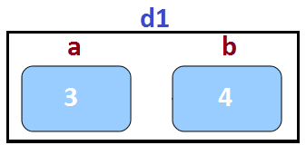 | 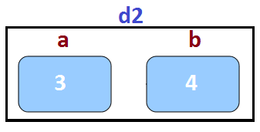

Shallow Copy
Creating copy of object by copying data of all member variables as it is.
Example:
Note: Shallow copy doesn’t occur when Object consist a pointer variable and that pointer variable pointing to the outer memory location. In this type of case we have to need the use Deep Copy Constructor. For deep copy we have to make copy constructor explicitly.
Note: If we use copy assignment operator , we must need to make it explicitly.
Example:

#include<stdio.h>
#include<conio.h>

class Dummy
{
private:
int a, b;

public:
void setData(int x , int y)
{
a=x ; b=y;
}

void showData()
{
cout<<"\n a= "<<a <<" b= "<<b;
}

};
void main()
{
clrscr();
Dummy d1;
d1.setData(3,4);
Dummy d2=d1; //using copy constructor which made by compiler
d2.showData();
getch();
/*
Or
Dumm y d2;
d2=d1;
d2.showData();
getch();
*/
}

Deep Copy
Creating an object by copying data of another object along with the value of memory resources resides outside the object but handled by that object.

Advantage Deep Copy
- For Deep Copy we have make copy constructor , with the help of this constructor we can make two different memory block for pointer member variable of object which is pointed to two different block, due to this perfect copy will happen.
- If we create same concept with the help of shallow copy then anyone object is destroy will free the address of pointed value which is pointed by that pointer member variable of destroy object. Due to this the pointer variable of second object which pointed to that address is change into Dangling pointer.

Example 1:
#include<iostream.h>
#include<conio.h>

class Dummy
{
private:
int a, b;
int *p;

public:
Dummy()
{
p=new int;
}

void setData(int x , int y, int z)
{
a=x ; b=y; *p=z;
}

void showData()
{
cout<<"\n a= "<<a <<" b= "<<b <<" *p= "<<*p;
}

Dummy(Dummy &d) //Copy Constructor, we made explicitly,Remember
{ //Compiler also make same copy constructor if we doesn't make it.
a=d.a ; b=d.b ; p=d.p ;
}

};
void main()
{
clrscr();
Dummy d1;
d1.setData(3,4,5);
Dummy d2=d1;
d2.showData();
getch();

}
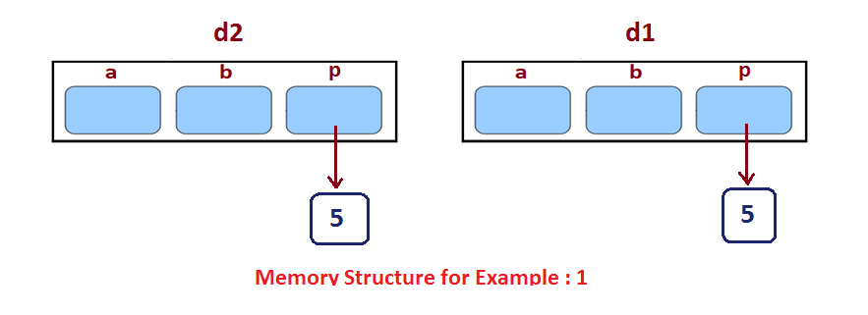
Example: 2
#include<iostream.h>
#include<conio.h>

class Dummy
{
private:
int a, b;
int *p;

public:
Dummy()
{
p=new int;
}

void setData(int x , int y, int z)
{
a=x ; b=y; *p=z;
}

void showData()
{
cout<<"\n a= "<<a <<" b= "<<b <<" *p= "<<*p;
}

Dummy(Dummy &d) //Copy Constructor made by programmer
{ //for deep copy ,we have had to make copy constructor explicit
a=d.a ; b=d.b ;
p=new int;
*p= *(d.p);
}

~Dummy() //In the concept of Deep Copy we have had to make
{ //destructor for deallocated or free pointed memory.
delete p;
}

};
void main()
{
clrscr();
Dummy d1;
d1.setData(3,4,5);
Dummy d2=d1;
d2.showData();
getch();

}

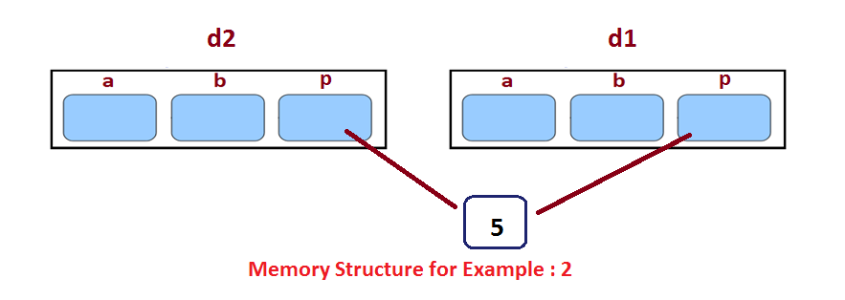

Primitive Type to Class Type in C++

Primitive type

Int, char , float, double are primitive types.

Class type is any class you defined

Why conversion is required ?

int x=4 ;

float y;

y=x ; // automatic type conversion

O/P : x= 3

IMP: Primitive Type To Class Type
Complex c1 ;
int x = 5 ;
c1 = x ; //error

Primitive type to class type can be implemented through constructor.
Example:
#include<iostream.h>
#include<conio.h>
class complex
{
private :
int a, b ;

public:
complex() // default constructor
{

}

complex(int k)
{
a=k ; b=0 ;
}

void setData(int x , int y)
{
a=x ; b=y;
}

void showData()
{
cout<<"\n a= "<<a<<" b= "<<b;
}

};

void main()
{
complex c1;
int x=5;
c1=x; //like c1.Complex(x)
c1.showData();
getch();
}

CLASS TYPE TO PRIMITIVE TYPE
Ex:
Complex c1;
c1.setData(3,4);
int x ;
x=c1; //error

Class type to primitive type can be implemented with casting operator.

operator type()
{
- - -
return(type-data);
}

Example:

#include<iostream.h>
#include<conio.h>
class complex
{
private :
int a, b ;

public:

void setData(int x , int y)
{
a=x ; b=y;
}

void showData()
{
cout<<"\n a= "<<a<<" b= "<<b;
}

operator int() //type casting
{
return(a);
}
};

void main()
{
complex c1;
c1.setData(3,4);
c1.showData();
int x;
x=c1; //like x=c1.operator int();
cout<<"\n x= "<<x;
getch();
}

One Class Type To Another Class Type Conversion.

Different Class Types

class item
{
int a, b;
- - -
};

class product
{
int m, n;
- - -
}

void main()
{
item i1;
product p1;
p1.setData(3,4);
i1=p1;
- - -
}
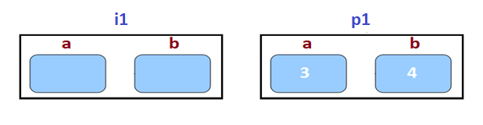

We can convert class type to another class type in two way.

Conversion through constructor

Conversion through casting operator

Question: In which class we will make construtor or casting operator ?

Ans:
Note:
Object_class_1 = Object_class_2 ;
If we use through constructor then constructor will make in class1.

If we use conversion through casting operator then casting operator implement in class2.

Example :
#include<iostream.h>
#include<conio.h>
class Product
{
private:
int m, n ;

public:

void setData(int x , int y)
{
m=x ; n=y;
}

int getM()
{
return(m);
}

getN()
{
return(n);
}

};

class item
{
private:
int a,b;

public:
void showData()
{
cout<<"\n a= "<<a<<" b= "<<b;
}
item()
{
}

item(Product p)
{
a=p.getM();
b=p.getN();
}

};

void main()
{
clrscr();
item i1;
Product p1;
p1.setData(3,4);
i1=p1;
i1.showData();
getch();
}

Exception Handling in C++
Exceptions
- Exception is any abnormal behavior, run time error.
- Exceptions are off beat situation in your program where your program should be ready to handle it with appropriate response.

Exception Handling
- C++ provides a built-in error handling mechanism that is called exception handling.
- Using exception handling, you can more easily manage and respond to runtime errors.

Try, catch , throw
- Program statements that you want to monitor for exceptions are contained in a try block.
- If any exception occurs within the try block, it is thrown (using throw).
- The exception is caught , using catch and processed.

Syntax :

try
{

}
catch( type1 arg)
{

}
catch(type2 arg)
{

}
…………
catch(typeN arg)
{

}

Note:
Try use with catch and catch use with try both are dependent to each other but throw are not depend to try as well as catch.

Example: Use throw without Try and Catch

#include<iostream.h>
#include<conio.h>
void main()
{
throw 10;
cout<<"\n throw use";
cout<<"\n last line"

getch();
}

Output:
terminate called after throwing an instance of 'int'

Note:
If value passes from throw is different type to catch (receiver value type) then same message/output occur as above show.
Example:

#include<iostream.h>
#include<conio.h>
void main()
{
try
{
throw 10;
cout<<"\n In try";
}
catch(double e)
{
cout<<"\n Exception no. "<<e ;
}
cout<<"\n Last Line";
getch();
}

Output:
terminate called after throwing an instance of 'int'

Example 3:
You can written more than one throw in one try block.

#include <iostream>

using namespace std;

int main()
{
int i=3;
cout<<"Welcome";

try
{
if(i==1);
throw 1;
if(i==2)
throw 2;
if(i==3)
{
throw 3;
}
cout<<"\n Message show no value thrown";
}

catch(int e)
{
cout<<"\n Exception no: "<<e;
}
cout<<" \nLast Line";
}

Output:

Welcome
Exception no: 1

Example 2:

Multiple catch block.
Multiple catch run one by one if thrown value is successfully catched by any catch block then compiler not execute next catches block further.

#include <iostream>

using namespace std;

int main()
{
cout<<"Welcome";
try
{
throw 10.4;
cout<<"\n In try" ;
}

catch(double e)
{
cout<<"\n Exception no :" <<e ;
}
catch(int e)
{
cout<<"\n Exception no :"<<e;
}

cout<<" \n Last Line ";

return 0;
}
Output:
Exception no: 10.4
Last Line

Example: 4
If we doesn’t know which type of value can be thrown from multiple throw and we want that exception catches by catch block then :

#include <iostream>

using namespace std;

int main()
{
int i=3;
cout<<"Welcome";

try
{
if(i==1);
throw 1;
if(i==2)
throw "hello";
if(i==3)
{
throw 4.5;
}
cout<<"\n thrown has not used";
}

catch(...)
{
cout<<"\n Exception occur ";
}

cout<<" \nLast Line";
}

Output:

Exception occur
Last Line

Example:

If we want to throw exception without any value, then no complile time error occur but at run time message show like “ terminate called without or active exception”

#include <iostream>

using namespace std;

int main()
{
int i=3;
cout<<"Welcome" ;
try
{
if(i==3)
throw;
cout<<"\n In Try";
}
catch (int)
{
cout<<"\n Exception no:";
}
cout<<"\n Last Line";

return 0;
}

Example: 6

It doesn’t message that catch receive thee value of throw or which passes from throw.
#include <iostream>

using namespace std;

int main()
{
int i=3;
cout<<"Welcome";
try {
if(i==3)
throw 10;
cout<<"\n In try";
}
catch(int)
{
cout<<"Exception Occur";
}
cout<<"\n Last Line";

return 0;
}

Example: 7
It doesn’t necessary that throw are written in try block. Iff the function which consist throw keyword is written in try block.
#include <iostream>

using namespace std;
void fun()
{
throw 10;
}
int main()
{
int i=3;
cout<<"Welcome" ;

try {
if(i==3)
fun();
cout<<"\n throw is not used";
}
catch(int e)
{
cout<<"\nException no :"<<e;
}
return 0;
}

Catch

When an exception is caught, arg will receive its value.

If you don’t need access to the exception itself, specify only type in the catch1 clause-arg is optional.

Any type of data can be caught, including classes that you create.

Throw

The general form at the throw statement is throw execution.

Throw must be executed either within the try block proper or from any function that the code within the block calls.

Dynamic constructor in C++
Revise
What is Constructor ?
Why use constructor ?

Dynamic constructor
Constructor can allocate dynamically created memory to the object.
This object is going to use memory region, which is dynamically created by constructor.

Example:

A(int x, int y, int z)
{
a=x;
b=y;
p=new int;
*p=z;
}

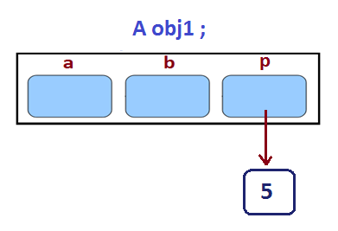

IMP:
Constructor which also initiate extra variable outside using pointer , this type of constructor called dynamic constructor.
Note:
Dynamic constructor is used to take decision for allocate the memory to the object at the run time.
Memory allocated decision taken at run time with the help of ‘new’ operator.

By using this constructor or dynamic constructor, we can dynamically initialize the objects.
Example:

Example 1:
#include <iostream>

using namespace std;

class A
{
private:
int a,b;
int *p;

public:
A() //constructor , compile time memory decision
{
a=0; b=0;
p=new int ; //address assign
}

A(int x, int y, int z) // Dynamic constructor, run time memory decision
{ //making memory for object e.g: z
a=x;
b=y;
p=new int ;
*p=z;
}
void showdata()
{
cout<<"\n a is "<<a<<" b is "<<b<<" *p is "<<*p;
}

};

int main()
{
A o1,o2,o3(3,4,5);
o3.showdata();
return 0;
}

Example 2:

#include <iostream>

using namespace std;

class DynamicCon
{
int *ptr;
public:
DynamicCon()
{
ptr=new int;
*ptr=100;
}

DynamicCon(int v)
{
ptr=new int ;
*ptr=v;
}

int display()
{
return(*ptr);
}

};
int main()
{
DynamicCon obj1, obj2(90);
cout<<"\n The value of obj1's ptr is :";
cout<<obj1.display();
cout<<"\n The value of obj2's ptr is :";
cout<<obj2.display();
return 0;
}

Virtual Destructor in C++

Revise :

What is destructor ?

Why should use destructor ?

new and delete.

Base pointer can point to the derived class.

Destructor in the Base class can be virtual , whenever upcasting is done, Destructor of the Base Class must be made virtual for proper destruction of the object when the proram exits.

Note: Constructor are never virtual , only Destructor can be virtual.

In order to define a virtual destructor, all you have to do is simply add the keyword “virtual” before the tilde symbol.

The need for virtual destructor in C++ is best illustrated by some example:

Let’s start by going through an example that does not use virtual destructors and then we will go through an example that does use virtual destructor, once you see the difference, you will understand why virtual destructors are needed.

Example: Without Virtual Destructor
#include <iostream>
using namespace std;

class Base
{
public:
~Base()
{
cout<<"Base Destructor";
}
};

class Derived: public Base
{
public:
~Derived()
{
cout<<"Derived Destructor";
}

};

int main()
{
Base *b=new Derived; //Early Binding occur or Compile Time binding
delete b;
return 0;
}

In the above example, delete b will only call the base class destructor, which is undesirable because, then the object of Derived class remains undestructed, because its destructor is never called, which results in memory leak.

Example: With Virtual Destructor

#include <iostream>
using namespace std;

class Base
{
public:
virtual ~Base()
{
cout<<"Base Destructor";
}
};

class Derived: public Base
{
public:
~Derived()
{
cout<<"Derived Destructor";
}

};

int main()
{
Base *b=new Derived; //Upcasting
delete b; //Late Binding occur or Runtime Time binding
return 0;
}

Output :

Derived Destructor
Base Destructor

When we have destructor inside the base class, the first Derived class’s destructor will call and then Base class’s destructor will call, which is the desired behavior.

Pure Virtual Destructor on C++

Pure virtual destructor are legal in standard C++ and one of the most important thing is that if class contains pure virtual destructor it is must to provide a function body for the pure virtual destructor. This seems strange that how a virtual function is pure if it requires a function body?
But destructors are always called in the reverse order of the class derivation. That means derived class destructor will be invoked first & then base class destructor will be called. If definition for the pure virtual destructor is not provided then what function body will be called during object destruction?
Therefore compiler & linker enforce existence of function body for pure virtual destructor.
Consider following program:
#include <iostream>

using namespace std;

class Base
{
public:
virtual ~Base()=0; // Pure virtual destructor
};

class Derived : public Base
{
public:
~Derived()
{
cout << "~Derived() is executed";
}
};

int main()
{
Base *b=new Derived();
delete b;
return 0;
}

The linker will produce following error in the above program.
test.cpp:(.text$_ZN7DerivedD1Ev[__ZN7DerivedD1Ev]+0x4c):
undefined reference to `Base::~Base()'

Now if the definition for the pure virtual destructor is provided then the program compiles & runs fine.

#include <iostream>

using namespace std;

class Base
{
public:
virtual ~Base()=0; // Pure virtual destructor
};

Base::~Base()
{
cout<<"Pure Virtual Destructor is called";
}

class Derived : public Base
{
public:
~Derived()
{
cout << "~Derived() is executed \n";
}
};

int main()
{
Base *b=new Derived();
delete b;
return 0;
}

It is important to note that class becomes abstract class when it contains pure virtual destructor. Hence we cannot create an object for that class.

Note:
As we know that if we don’t override pure virtual function in derived class then it becomes abstract class.

In the case of pure virtual destructor in base class, the derived class doesn’t become abstract because default destructor call for derived class then default overriding occur for pure virtual destructor.

IMP
Normally, a pure virtual function in a base class would cause the derived class to be abstract unless it (and all other pure virtual functions) is given a definition.
But here , this seems not to be the case, However, remember that the compiler automatically create a destructor definition for every class if you don’t create one. That’s what’s happening here the base class destructor is being quirtly overridden, and thus the definition is being provided by the compiler and Derived is not actually abstract.

Namespaces in C++
Requirment : 32 bit or 64 bit compiler
Basic : #include<stdio.h>

Remember :

- Header file consist declaration of functions, variable, classes or many identifier.
- And Defination of predefined identifiers/ functions are written in library files.

- In C++ 32 bit or 64 bit compiler make changes in declaration of identifier in header files.

- In 32 bit and 64 bit compiler the declaration of identifier or group of declaration are stored in one group called namespace.
- We can give the name to the namespace
e.g :
namespace My Space
{
………
………
………
}

- Note: We can code namespace in our source or external file (make header file) with extension dot(.) .h.

namespace is nothing but a group of declaration.
Note : In 16 bit compiler or old compiler the declaration is maintain without namespace keyword in header file( iostream or stdio).

Advantage by namespace :

If in any program we have include two header files, /and Both header files have same function/variable declaration. Then ambiguity can occur.(name collision).
Problem Occur : In one program two declaration for one identifier.

Namespace:

Namespace is a container for identifiers.
It put the names of its members in a distinct space so that they don’t conflict with the names in other namespaces or global namespaces.

How to create namespace ?
Namespace MySpace{
//Declaration
}

Namespace definition doesn’t terminates with a semicolon like in class definition.
The namespace definition must be done at gloabal scope, or nested inside another namespace.
You can use an alias name for your namespace name , for case of use.
e.g: namespace ms=”MySpace”;

Remember:
Namespace is not a class , you cannot create instance of namespace.

Unnamed namespaces
There can be unnamed namespaces too.
Namespace
{
//declaration
}

Namespace can be extended.
A namespace definition can be continued and extended over multiple file. They are not redefined or overridden.

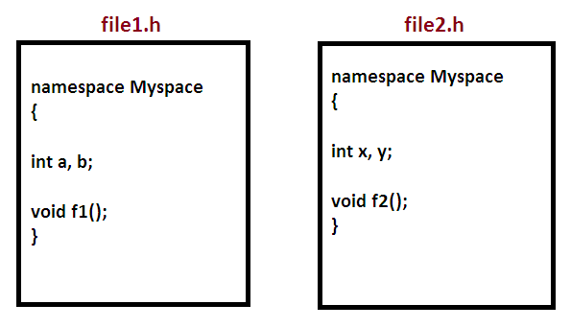

Note: No name Conflict
Compiler will combine both Myspace and consider single Myspace.

Accessing members of namespace.

Any name (identifier) declared in a namespace can be explicitly specified using the namespace’s name and the scope resolution :: operator with the identifier.
Namespace Myspace
{
int a,b;
voidf1()
}

Example
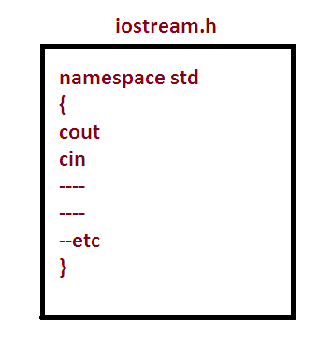

Example 1:
#include<iostream>
namespace Myspace
{
int a;
int f1();
class A
{
public:
void fun1();
};

}

int f1()
{
std::cout<<"Hello f1";
}

int main()
{

Myspace:: a=5;

return 0;
}

Note:
Use of “using namespace” are show in Example 1 and Example 2. We can use “using namespace” in external namespace (like std) as well as internal namespace(like Myspace) shown in Example 2.

Note: using namespace concept used for when we use identifier, never used in declaration and definition of identifier.

Example 2:

#include<iostream.h>
using namespace std;

namespace Myspace //external namespace
{
int a;
int f1();
class A
{
public :
void fun1();
};

}

int Myspace::f1()
{
cout<<"Hello f1";
}
using namespace Myspace; //internal namespace
void main()
{
a=5 ;
}

//If we have two namespace in one program and both
have same name variable then we need to use namespace
name and scope resolution operator for using that variable.
e.g:
Myspace:: a=5;
Myname :: a=19;

Example 3:
#include<iostream>
using namespace std;

namespace Myspace
{
int a;
int f1();
class A
{
public :
void fun1();
};

}

int Myspace::f1()
{
cout<<"Hello f1\n";
}

void Myspace::A::fun1()
{
cout<<"Hello fun1 \n";
}

using namespace Myspace;
int main()
{
a=5;
f1();
A obj;
obj.fun1();
return 0;
}

Output:

Hello f1
Hello fun1

The using directive

Using keyword allow you to import an entire namespace into your program with a global scope.

It can be used to import a namespace into another namespace or any program.

Example:

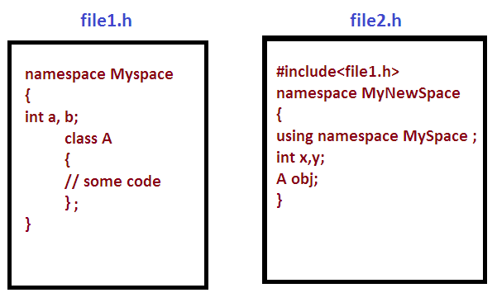

Nested Class

Class inside a class is called nested class.

A nested class is a member and as such has the same access rights as any other member.

The members of an enclosing class have no special access to members of a nested class, the usual access rules shall be obeyed.

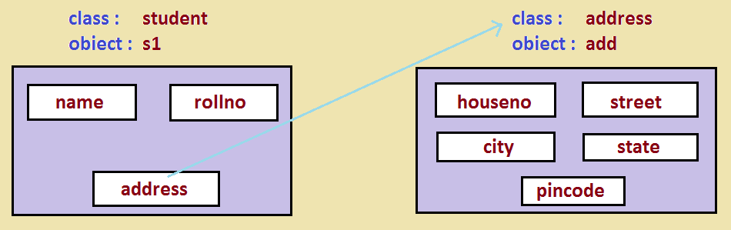

Member functions of class cannot be access the private member of their nested class.

Private member of class only accessible by their own member function.

Example:

#include<iostream>
#include<string.h>
using namespace std;

class student
{
private:
int rollno;
char name[20];

public:
class Address
{
private:
int houseno;
int street[20];
char city[20];
char state[20];
char pincode[7];

public:
void setAddress(int h, char *s, char *c, char *st, char *p)
{
houseno=h;
strcpy(street,s);
strcpy(city,c);
strcpy(state,st);
strcpy(pincode,p);
}

void showAddress()
{
cout<<"\n"<<houseno;
cout<<"\n"<<street;
cout<<"\n"<<pincode;
cout<<"\n"<<state;
}

};

Address add;

public:
void setRollno(int r)
{
rollno=r;
}

void setName(char *n)
{
strcpy(name,n);
}

void setAddress(int h, char *s, char *c, char *st, char *p)
{
add.setAddress(h,s,c,st,p);
}

void showStudent()
{
cout<<"Student Data"<<endl;
cout<<rollno<<" ";
cout<<name<<" ";
add.showAddress();
}
};

int main()
{
//Address a1; //error , we cannot create object of nested class like this in outside class/ main()

student::Address a1; //we can create object of nested class in main()/outside-class iff nested class is in public.
student s1;
s1.setRollno(100);
s1.setName("Rahul");
s1.setAddress(301,"hanuman gali","indore","452001","MP");
s1.showStudent();

return 0;
}

//Q.1: How to make object of nested class(inside and outside the enclosed class ?

//Q.2: What is the role of access modifier for nested class?

Intoduction to STL in C++
template <class x>
class list
{
x a[10];
};
list <float> obj ;
Or
list<student> obj2;

STL

STL is standard Template Library

It is a powerful set of c++ template classes

At the care of the c++ standard Template Library are following three well structured components.

Containers

Algorithms

Iterators

Containers

Containers are used to manage collections of objects of a certain kind.

Container library in STL provide containers that are used to create data structures like array, linked list, trees etc.

These container are generic , they can hold elements of any data types.

Example:

Vector can be used for creating dynamic arrays of char , integer, float and other types.

Algorithms

Algorithms act on containers. They provide the means by which you will perform initialization , sorting, searching and transforming of the contents of containers.

Algorithms library contains built in functions that performs complex algorithm on the data structures.

Example: One can reverse a range with reverse() function, sort a range with binary_search() and so on.

IMP: Algorithm library provides abstraction, i.e you don’t necessarily need to know the algorithm works.

Iterators

Iterators are used to step through the elements of collections of objects. These collections may be containers or subsets of containers.

Iterators in STL are used to point to the containers.

Iterator actually acts as a bridge between containers and algorithms.

Example :

Sort() algorithm have two parameters, starting iterator and ending iterator, now sort() compare the elements pointed by each of these iterators and arrange them in sorted order, thus it does not matter what is the type of the container and same sort() can be used on different types of containers.

Container

Container library is a collection of classes.

The containers are implemented as generic class template.

Containers help us to implement and replicate simple and complex data structures very easily like array, list . trees, associative array and more.

Containers can be used to hold different kind of object.

Common Containers

vector : replicates array

queue : replicates queues

stack : replicates stack

priority-queue : replicate linked list

set : replicates trees

map : associative array

Classifications of container

Sequence Containers

-like array, linked list etc.

Associative Containers

-Sorted Data Structure like map, set etc.

Unsorted Associative Containers.

-Unsorted Data Structures.

Containers Adapters

-Interface to sequence containers.

How to use container library?
When we use list containers to implement linked list we just have to include the list header file and use list constructor to initialize the list.

#include<iostream>
#include<list>
void main()
{
list<int>mylist;
}

Array in STL

Array
Array is a linear collection of similar elements.
Array container in STL provides us the implementation of static array.
Use header array.
-#inlcude<array>

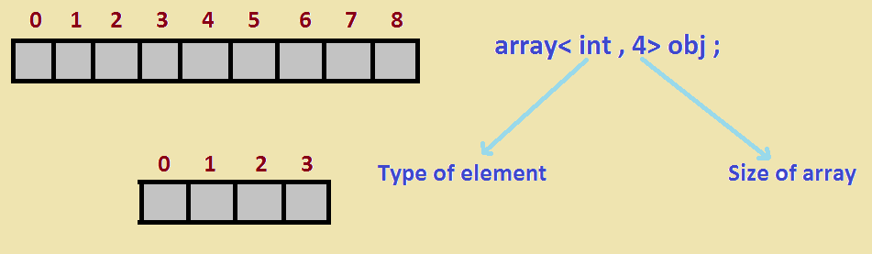

Syntax :
array<obj_type, array_size> array_name;

It creates an empty array of object_type with maximum size of array_size.

IMP:
Assignment of values during declaration
array<int , 4> odd_number = { 2,4,6,8 } ;

Example: Array in STL

#include<iostream>
#include<array>
using namespace std;

void main()
{
array<int,5> data_array={11,22,33,44,55};
}

Now Compile and Run

May be program will show an error like

Error message :

This file requires compiler and library support for the ISO c++ 2011 standard. This support is currently experimental, and must be enabled with the -std=c++11 or -std=gnu++11 compiler options.

Sol for error

In your programming software

e.g.: code blocks software

Go to setting

Select compiler

Under compiler setting tab

Under compiler flags tab

Check –std=c++11

Now error will solve and program will run successful.

Member functions

Following are the important and most used member functions of array template.
- at
- [] operator
- front()
- back()
- fill()
- swap()
- size()
- begin()
- end()

- at()
This method returns value in the array at the given range.
If the given range is greater than the array size, out_of_range exception is thrown.

Example:

#include<iostream>
#include<array>
using namespace std;
int main()
{
array<int,5> data_array={11,22,33,44,55};
cout<<data_array.at(2);

return 0;
}

Output: 33
- [ ]operator
The use of operator[] is same as it was for normal arrays.

#include<iostream>
#include<array>
using namespace std;
int main()
{
array<int,5> data_array={11,22,33,44,55};
cout<<data_array[3];

return 0;
}

Output: 44

- front() and back()

front() method returns the first element in the array.

back() method returns the last element in the array.
#include<iostream>
#include<array>
using namespace std;
int main()
{
array<int,5> data_array={11,22,33,44,55};
cout<<data_array.front();
cout<<data_array.back();

return 0;
}

Output: 11 55

- fill() : This method assign the given values to array element of the array.
Note: Only single value assign in all index.
#include<iostream>
#include<array>
using namespace std;
int main()
{
array<int,5> data_array={11,22,33,44,55};
data_array.fill(10);
for(int i=0; i<=7; i++)
cout<<data_array[i];

return 0;
}

Output: 10 10 10 10 10 10 10

- swap()
- This method swap the content of two arrays of same type and same size
- If swap index wise, thus element of index i of first array will be swapped with the elements of index i of the second array.
- first_array.swap(second_array)
Example:

#include<iostream>
#include<array>
using namespace std;
int main()
{
array<int,5> data_array1={11,22,33,44,55};

array<int,5> data_array2={1,2,3,4,5};

data_array.swap(data_array2);

for(int i=0; i<=4; i++)
cout<<data_array1[i];

cout<<endl;

for(int i=0; i<4; i++)
cout<<data_array2[i];

}

Output: 1 2 3 4 5
11 22 33 44 55

- size() :
This method returns the number of element present in the array.

#include<iostream>
#include<array>
using namespace std;
int main()
{
array<int,5> data_array={11,22,33,44,55};

cout<<"Size is"<<data_array.size();
}

Output: Size is 5
- begin() and end()
begin() method returns the iterator pointing to the first element of the array.
end() method returns on iterator pointing to an element next to the last element in the array.

Note: This topic we will learn later, in section of iterator.

Pair in STL

Pair is a template class in Standard Template Library.
Pair is not a part of container

Syntax of using pair object

pair<T1 , T2> pair1 ;

Example:

pair<string, int> p1 ;

Programing Example:

#include<iostream>
using namespace std;
class Student
{
private ;
string name;
int age;

public:

void setStudent(string s, int a)
{
name=s;
age=a;
}

void showStudent()
{
cout<<"\n Name: "<<name;
cout<<"\n Age: "<<age;
}

};

void main()
{
pair<string, int> p1;
pair<string,string> p2;
pair<string, float> p3;
pair<int , student> p4;

p1=make_pair("Rahul",16);
p2=make_pair("India", "New Delhi");
p3=make_pair("Drilling C++",34.5f);

Student s1;
s1.setStudent("Aishwarya",19);
p4=make_pair(1,s1);

cout<<"\n Pair 1";
cout<<"\n"<<p1.first<<" "<<p1.second;

cout<<"\n Pair 2";
cout<<"\n"<<p2.first<<" "<<p2.second;

cout<<"\n Pair 3";
cout<<"\n"<<p3.first<<" "<<p3.second;

cout<<"\n Pair 4";
cout<<"\n"<<p1.first;

Student s2= p4.second ;
s2.showStudent();

}

Output :

Pair 1
Rahul 16

Pair 2
India New Delhi

Pair 3
Drilling C++ 345.5

Pair 4
1

Name: Aishwarya
Age : 19

Compare two pairs

- == e.g: p1==p2
- !=
- <
- >
- <=
- >=

Tuple in STL in C++

Tuple
Just like in pair, we can pair two heterogenous objects in tuple we can pair multiple objects.
Syntax of using tuple object

tuple<T1 , T2 , T3> tuple1;

Example : tuple<string , int , int> t1 ;

Inserting Value

T1 = make_tuple(“India” , 16 , 10 ) ;

Accessing tuple members.

tuple< string, int , int> t1 ;
t1 = make_tuple(“India”, 16 , 10);

cout<<std::get<0>(t1);
cout<<std::get<1>(t1);
cout<<std::get<2>(t1);

Programing Example:

#include<iostream>
#include<tuple>
using namespace std;

void main()
{
tuple<string, int , int> t1;
t1= make_tuple("Rahul", 15, 30);

cout<<get<0>(t1)<<" ";
cout<<get<1>(t1)<<" ";
cout<<get<2>(t1)<<" ";

}

Note: Compare two tuples
- ==
- !=
- <
- >
- <=
- >=

Vector class in STL in C++

Vector

- The most general purpose container is the vector.
- It supports a Dynamic Array.

What is Dynamic Array
- Array size is fixed, no flexibility to grow or shrink during exection.
- Vector can provide memory flexibility.

Vector Size
Vector being a dynamic array, doesn’t needs size during declaration. Size can be declare.
Code below will create a blank vector
Vector<int> v1;

Note:
- In vector, memory dynamically increase with the rate double of current vector size.
- Default vector object capacity initially is 0.

Initialize during declaration

e.g : vector<string> v { “Saurabh” , “Ravi”};

More vector declarations
vector<int> v1 ;
- zero length vector
vector<char> ch(5);
creates a 5 element char vector

vector <char> cv(4 , ‘a’);
Initializes 4 elements char vector with a
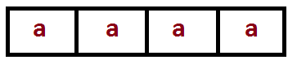
vector <string>cv(3 , “hello”);
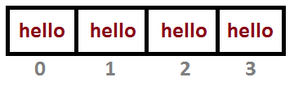

Also All these operators work on vector
- ==
- !=
- >
- <
- >=
- <=

- Subscript operator[ ] // use for print values of vector
Subscript operator is also defined for vector.
e.g : vector<string> v4(3, “hello”);
cout<<v4[0]<<endl ;

Output: hello

push_back()
push_back() is a member function, which can be used to add value to the vector at the end.

e.g:

#include<iostream>
#include<vector>
using namespace std;
void main()
{
vector<int> v1;
cout<<"current capacity is "v1.capacity()<<endl;

v1.push_back(10);
cout<<"Current capacity"<<v1.capacity();

v1.push_back(20);
cout<<"Current capacity is "<<v1.capacity();

v1.push_back(30);
cout<<"Current capacity is "<<v1.capacity();
}

pop_back()

It removes the last element.
e.g:

#include<iostream>
#include<vector>
using namespace std;
void main()
{
vector<int> v1;
cout<<"current capacity is "v1.capacity()<<endl;

for(int i=0; i<=9; i++)
v1.push_back(10*(i+1));
cout<<"Current capacity is"<<v1.capacity();

v1.pop_back();
cout<<”current capacity is ”<<v1.capacity();

v1.pop_back();
cout<<”current capacity is ”<<v1.capacity();

}

Output : 16 16 16

Note: Capacity is never reduce when we pop an element from vector.

capacity()
It return the capacity of the vector.
This is the number of elements it can hold before it will need to allocate more memory.

size()
It returns the number of elements currently in the vector.

Example:
#include<iostream>
#include<vector>
using namespace std;
void main()
{
vector<int> v1;
cout<<"current capacity is "v1.capacity()<<endl;

for(int i=0; i<=9; i++)
v1.push_back(10*(i+1));
cout<<"Current capacity is"<<v1.capacity();

v1.pop_back();
cout<<”current capacity is ”<<v1.capacity();

cout<<"Total number of elements are"<<v1.size();

}

Output:
0
16
16
9

IMP: Important use of size() in vector is to print the value of vector
Example:.

#include<iostream>
#include<vector>
using namespace std;
void main()
{
vector<int> v1;
cout<<"current capacity is "v1.capacity()<<endl;

for(int i=0; i<=9; i++)
v1.push_back(10*(i+1));

cout<<"Current capacity is"<<v1.capacity();

for(int i=0; i<v1.size(); i++)
cout<<endl<<v1[i];

}

clear()

It removes all elements from the vector.

Example:

#include<iostream>
#include<vector>
using namespace std;
void main()
{
vector<int> v1;
cout<<"current capacity is "v1.capacity()<<endl;

for(int i=0; i<=9; i++)
v1.push_back(10*(i+1));

v1.clear()
cout<<"Current Capacity is :"<<v.capacity();
cout<<"Total elements "<<v1.size();

Output:
Current Capacity is 0
Current Capacity is 16
Total elements 0

at()
This method works same in case of vector as it works for array.
It returns the element at ith index in the vector vector_name.

#include<iostream>
#include<vector>
using namespace std;
void main()
{
vector<int> v1;
cout<<"current capacity is "v1.capacity()<<endl;

for(int i=0; i<=9; i++)
v1.push_back(10*(i+1));

cout<<"Value at index 3 is"<<v1.at(3);

}

front() and back()

front() returns the first element of the vector

back() returns the last element of the vector

e.g :
cout<<”1st value is ”<<v1.front() ;
cout<<”Last value is ”<<v1.back() ;

Iterator

The concept of an iterator is fundamental to understanding the C++ Standard Template Library (STL), Because iterators provide a means for accessing data stored in container classes such as vector, map, list , etc.

You can think of an iterator as pointing to an item that is part of a larger container of items.

Iterator used in vector for insert value in anywhere in vector.

In list for print value of list.

In MAP for print index as well as value/elements of MAP

Example:
#include<iostream>
#include<vector>
using namespace std ;
void main()
{
vector<int> v1;

for(int i=0; i<=9; i++)
v1.push_back(10*(i+1));

for(int i=0; i<v1.size(); i++)
cout<<v1.[i];

vector<int>::iterator it=v1.begin();
v1.insert(it+2, 35); //index 2

for(int i=0; i<v1.size(); i++)
cout<<v1[i];

}

Output:
10 20 30 40 50 60 70 80 90 100
10 20 35 30 40 50 60 70 80 90 100
}

List class in STL

List
List class support a biderection, linear list.

Vector supports random access but a list can be accessed sequentially only.
List can be accessed front to back or back to front.

Creating List Object

list<int> l1
list<int>l2{11,22,33,44};
list<string>l3{“Delhi”,”Dhaka”,”Kathmandu”,”Islamabad”};

Example:
#include<iostream>
#include<list>
using namespace std;
int main()
{
list <int>l1{l1, l2, l3};
list<string>l2{"Delhi", "Dhaka", "Kathmandu","Islamadaad"};
list<int>:: iterator p=l1.begin(); // p is pointer ,made by iterator
while(p!=l1.end())
{
cout<<*p<<" ";
p++;
}
}

Output: 11 22 33

Usefull functions of list class.
- sort()
- size()
- push_back()
- push_front()
- pop_back()
- pop_front()
- reverse()
- remove()
- clear()
1) size():
return the total no. of value in list.
e.g: cout<< "Total value in the list are "<<l1.size();

Output: 3
2) push_back()=insert value in the last index of the list
push_front()=insert value in the front index of the list

e.g:

list<string>l2{"India", "US", "Eng", "UK"};

l2.push_back("Bhopal");
l2.push_front("Karachi");

list<string>::iterator p=l2.begin()

while(p!-i2.end())
{
cout<<*p<<" ";
p++;
}

cout<<"Total value in the list are "<<l2.size();
}
}

Output:
Karachi India Us Eng UK Bhopal
Total value in the list are 6

3)
pop_back() : Delete last value of lsit
pop_front() : Delete first value of list
Example:
void main()
{
list <int> l1(11,22,33);

list <int>:: iterator p=l1.begin();
while(p!=l1.end())
{
cout<<*p<<" ";
p++;
}

cout<<endl;
l1.pop_back(); //or l1.pop_front();

while(q!= l1.end())
{
cout<<*q<<" ";
q++;
}
}

Output:

for pop_back() for pop_front()
// 22 33 //22 33
// 22 //22 33

4) reverse() : reverse the elements of the list.
5) sort() : sort element of list in arranging order.

Example for both reverse and sort:
#include<iostream>
#include<list>
using namespace std;
void main()
{
list<int>l1{55,22,77,44,66,99,88,11};

list<int>::iterator p=l1.begin();

while(p!=l1.end())
{
cout<<*p<<" ";
p++;
}
cout<<endl;
l1.sort(); //l1.reverse();
list<int>::iterator q=l1.begin();
while(q!=l1.end())
{
cout<<*q<<" ";
q++;
}
};

Output :

for reverse()

55 22 77 44 66 99 88
88 99 66 44 77 22 55

for sort()
55 22 77 44 66 99 88
22 44 55 66 77 88 99

6) remove() : remove element in the list which we want to remove.

Example:

list<int>l1{55,22,77,44,66,99,44,11};
l1.remove(44); //if 44 exist two times than both the value will remove
list<int>::iterator q=l1.begin();
while()q!=l1.end())
{
cout<<"*q"<<" ";
q++;
}

Output:
55 22 77 66 99

7) clear()
clear the list
e.g: l1.clear();

Map class in STL
Map is same as associative array

-Map are used to replicate associative arrays.
-Map contains sorted key-value pair, in which each key is unique and cannot be changed, and it can be inserted or deleted but cannot be altered.

What is associative arrays.

Generally arrays are two types.

1) Numeric array

like:
int a[5];

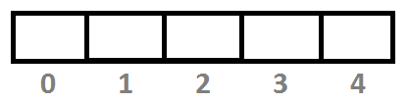
float b[4];
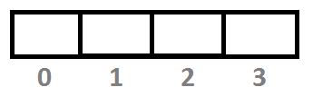
string s[3];
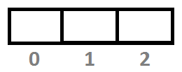

Defination: An array with a numeric index value are stored and accessed in linear fashion.

2) Associative array: An array with string or any type as index. This store element values in association with key values rather than in a strict linear index order.

Example: int m[20] ;
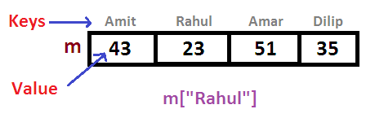
Example:
Customer Number | Customer name
100 | Gajendra
123 | Dilip
145 | Aditya
171 | Shahid
200 | Rajesh

Map Property

Map always arrange its keys in sorted order.

In case the keys are of string type, they are sorted in dictionary order.

How to create MAP with string index.
Mao<string, string> customer;

customer[‘Maharashtra’]=”Gajendra”;
customer[‘Gujrat’]=”Dilip”;
Note: Don’t keep associative array index with double quate iff index/key are strings.

How to create a map?
map<int,string> customer ;

customer[100]=”Gajendra”;
customer[123]=”Dilip”;
customer[145]=”Aditya”;
customer[171]=”Shahid”;
customer[200]=”Rajesh”;

Example:
#include<iostream>
#include<map>
Using namespace std;

void main()
{
map<int, string> customer;
customer[100]=”Gajendra”;
customer[123]=”Dilip”;
customer[145]=”Aditya”;
customer[171]=”Shahid”;
customer[200]=”Rajesh”;
or
map<int, string> c{ {100, “ Gajendra” }, { 123, “Dili” }, { 145, “Aditya” }, { 171, “Shahid” }, { 200, “ Rajesh”} };
cout<<customer[100]<<endl;
cout<<customer[123]<<endl;
}

Print map value using iterator( useful when we want to print more than one value or begin (starting) to end value)

Example:
#include<iostream>
#include<map>
Using namespace std;

void main()
{
map<int, string> customer;
customer[100]=”Gajendra”;
customer[123]=”Dilip”;
customer[145]=”Aditya”;
customer[171]=”Shahid”;
customer[200]=”Rajesh”;

map <int, string>::iterator p=customer.begin();

while(p!=customer.end())
{
cout<<p->second<<endl; // for value
cout<<p->first<<endl; //for index
p++;

}

}

Usefull function of map class

at()

[]

size()

empty()

insert()

clear()

at() : return value at mention index.

e.g : cout<< customer.at(145);

size() : return no. of values in MAP

e.g : cout<<customer.size();

empty(): To check MAP is empty or not , it return 0 if empty and it return 1 if doesn’t empty.

e.g: cout<<customer.empty();

clear() : To delete all the data from MAP

e.g : customer.clear();

insert() : To insert an element into MAP at the end, in this we need to make pair in the function.

e.g: customer.insert(pair<int, string> (205, “Saurabh”));

